National University – Clark

INTEGRATIVE PROGRAMMING

1st Term A.Y. 2026-2027

MyGameVault - A Video Game Collection Web Application

Presented by:

Students Name:
Mendiola, Christian Kal-El B.
Miranda, Christian Dave N.
Sarmiento, Winross Therence B.

Bachelor of Science in Information Technology

Instructor’s Name:

Mr. Adrian Lee G. Magcalas, MSIT

Date of Submission:

October 2026

DELIVERABLES

I. Contribution of each Member

Christian Kal-el B. Mendiola : API Integration and Backend

Winross Therence B. Sarmiento : Documentation and Backend

Christian Dave N. Miranda : Frontend

II. System Description
MyGameVault is a full-stack video game database and personal collection management web application that converges real-time external gaming data with a custom library organization. Powered by an asynchronous Express.js backend and the RAWG API, this platform enables users to discover online titles by searching the RAWG database, to see each game's release year, platforms, rating and genres, and to open a detail page with screenshots, system requirements and store links. Other than public search capabilities, registered users can curate their personal collection by saving external titles with a single click, manually adding custom video games missing from online databases, or managing a wishlist for desired releases. Built on RESTful API principles with lightweight persistent storage in JSON files, the system delivers complete CRUD functionality, allowing gamers to look up, create, edit, and delete items to maintain an organized digital library across sessions. Players can also discuss a game in its forum, set a profile picture, and add friends so that they can see each other's collection and wishlist.
The application is served by a single Node.js process. The same Express server hosts the web pages (the public folder) and the REST API (/api/...), so running one command starts the whole system. No separate database server and no build step are needed.
Table 1. Technology stack
Layer | Technology | What it does in MyGameVault
Server | Node.js, Express 5 (^5.2.1) | Serves the web pages and the REST API; routing, JSON parsing, static files.
External data | RAWG Video Games Database API through axios (^1.20.0) | Game search, game details with screenshots, and the trending list.
Cross-origin access | cors (^2.8.6) | Allows browsers on other origins to call the API.
Storage | JSON files read and written with Node's fs module | Saved games, wishlist, accounts, sessions, forum comments and friendships; profile pictures as JPEG files.
Security | Node crypto (scrypt, SHA-256, random bytes) | Password hashing, session tokens and their fingerprints.
Frontend | HTML, CSS and plain JavaScript (no framework) | Single-page interface with hash-based navigation and a neo-brutalist theme.
Testing and delivery | Node's built-in test runner, Docker, Jenkins | Automated tests of the test-plan cases, a three-stage Docker image and a Jenkins pipeline that runs them.

III. Parts and Features of the System
The features of the system include searching an external database (RAWG), and using that data, together with a user account, a user can add those games into their collection or wishlist, talk about them in forums, and connect with other players.
The UI is split into five main tabs on the navigation bar (Home, My Games, Wishlist, Look Up Online and Add a Game). Three more features (Forums, Profile and Friends) are reached from a game's detail page and from the player's name at the top right of every page.
- Home
  - Shows the current trending games from RAWG's "New and trending" list: twelve numbered cards that can be added to the collection or the wishlist straight from the page. The list is refreshed hourly.
- My Games
  - Lets the user see the list of games they have added, both online (from RAWG) and offline (typed in by hand). The list can be filtered, edited, deleted, and each game can be opened for more details.
- Wishlist
  - Lets the user look at all of their games that they wishlisted, move one to the collection, or remove it.
- Look Up Online
  - Allows the user to search a game with the exact or similar title in the RAWG database (up to five matches are shown).
- Add a Game
  - Allows the user to manually add a game that is not in the RAWG database, along with its attributes such as developer, publisher, platforms, rating and release year.
- Forums
  - Allows signed-in players to communicate under a specific game: every game has its own comment thread on its details page, with likes and dislikes. Anyone can read a thread.
- Profile
  - Gives each member a profile picture, a summary (collection size, wishlist size, friends, member since) and shelves that show off the collection and wishlist for friends to view.
- Friends
  - Allows users to connect with other people (send, accept, decline or cancel requests, and unfriend) and see what their collections and wishlisted games are.

Access levels
Nobody has to sign up before using the app. The first time a visitor does something that needs a session, the server creates a temporary guest account and a session for it. A guest can read the trending list, search RAWG, open game details and read forums, but adding games, posting and the other member features need a real account. Creating an account turns the visitor into a member.
Table 2. What guests and members can do
Feature | Guest | Member
Trending, Look Up Online, game details | Yes | Yes
Add to the collection or wishlist, move a wishlisted game | No (403); the page asks the visitor to sign in | Yes, saved to the account
View, edit and delete saved games | Nothing to show, because a guest cannot add games | Yes, the member's own games only
Read a game's forum | Yes | Yes
Post, like or dislike, delete own comments | No (403) | Yes
Profile picture, player profiles | No (403) | Yes
Friends: add, accept, decline, remove | No (403) | Yes

Other parts of the system
- Console tiles. Fifteen platform tiles (PC, PlayStation, Xbox, Switch, DS, Game Boy, NES, SNES, N64, GameCube, Wii, Sega, Arcade, Mobile and Other). RAWG platform names such as "PlayStation 5" are matched to a tile with regular expressions, and the same tiles are used as placeholder covers.
- Game details page. About text, details, tags, system requirements, a screenshot gallery with a full-screen viewer, and the official stores that sell the game.
- Edit page. A separate page (edit.html) with the same fields as the Add a Game form; only the fields that changed are sent to the server.
- Accounts and security. Passwords are stored as scrypt hashes, sessions use random tokens of which only a SHA-256 fingerprint is kept, and repeated wrong passwords are throttled.
- Feedback. Loading skeletons, toast messages, empty-state hints with links, and a two-step Delete button ("Sure?") protect the user from mistakes.
IV. Database Schema
MyGameVault does not use a database server. Its data is stored as JSON arrays in plain files that the backend manages through the small module db.js. Each file is created automatically (with []) the first time the server starts, and profile pictures are kept as image files in an avatars folder.
db.js gives every file a read() and a write(list) function. write saves the whole list as formatted JSON; if a file is ever damaged, read throws an error instead of silently starting over, so existing data is never overwritten by mistake. The folder for all data files can be changed with the DATA_DIR environment variable. New record ids come from db.newId, which uses the current time in milliseconds and moves past the highest id already in the file, so two records never share an id.
Table 3. Data files
File | Holds | Key | Linked by
users.json | Members and guests | id | -
sessions.json | Active sign-ins | token (fingerprint) | userId to users
library.json | Saved games (My Games) | id | userId to users
wishlist.json | Wishlisted games | id | userId to users
comments.json | Forum comments | id | userId to users, gameKey to a game
friends.json | Friend requests and friendships | id | from and to to users
avatars/<userId>.jpg | Profile pictures (files) | file name | named after the user's id

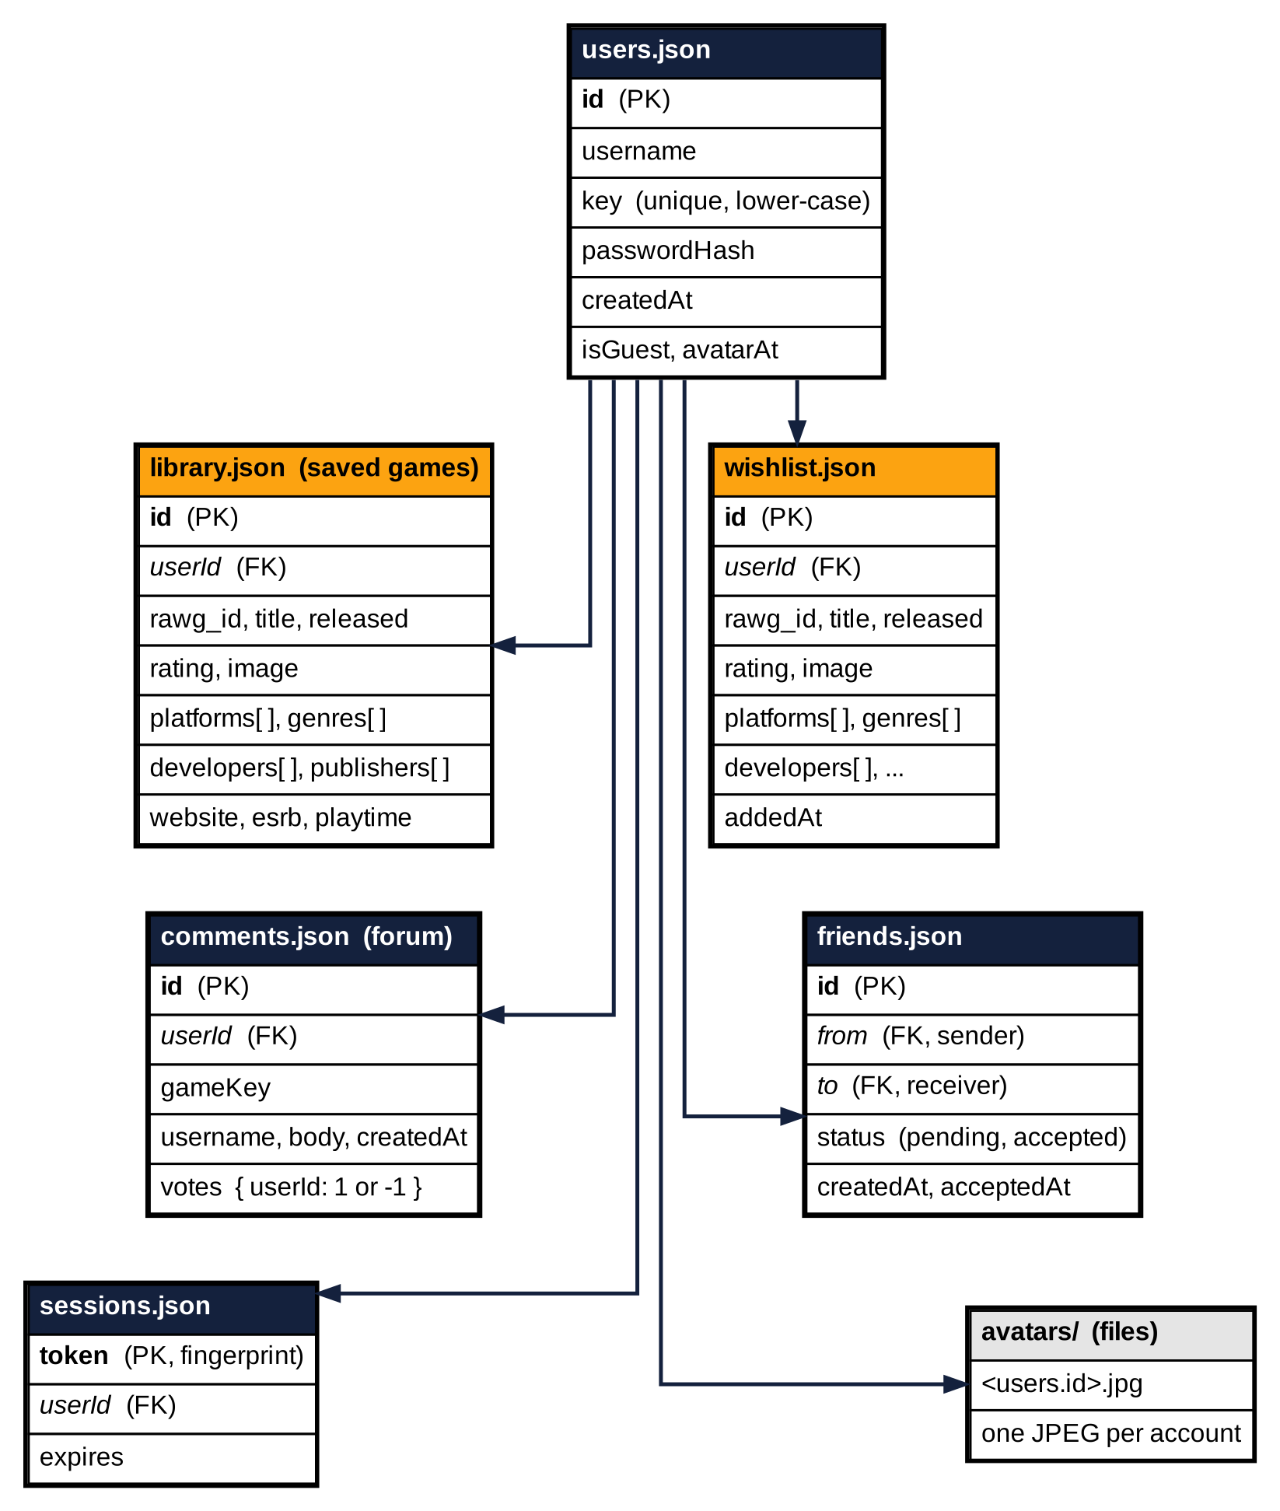
Figure 1. Entity relationship diagram of the JSON data files. Each arrow runs from one account (users.json) to the many records that belong to it; an account has at most one picture in avatars/.

users.json
Field | Type | Description
id | string | Primary key. A UUID for members, guest_ plus eight characters for guests.
username | string | Display name, 3 to 24 characters (letters, numbers, dots, dashes, underscores; must start with a letter or number).
key | string | Lower-case copy of username. Unique, so "Player_One" and "player_one" cannot both exist.
passwordHash | string | scrypt$N$r$p$salt$hash (members only). The password itself is never stored.
createdAt | ISO date | When the account was created.
isGuest | boolean | true for guest accounts only.
avatarAt | ISO date | Optional. When the profile picture was last set; also used as the picture's version in its URL.

sessions.json
Field | Type | Description
token | string | Primary key. SHA-256 fingerprint of the session token; the token itself is only ever in the user's cookie and browser storage.
userId | string | Foreign key to users.id.
expires | number | Expiry time in milliseconds. Sessions last 30 days.

library.json and wishlist.json
Both files hold game records of the same shape. A wishlist record also has addedAt. Games chosen from RAWG carry the RAWG id and the RAWG details; games added by hand only carry what the form collected.
Field | Type | Description
id | number | Primary key, generated by the server.
userId | string | Owner. Foreign key to users.id; every query is limited to the signed-in owner's records.
rawg_id | number | RAWG's id for the game. Missing for games added by hand.
title | string | Game title (required for the wishlist; required by the forms).
released | string | Release date (2026-08-27) or just a year for hand-added games.
rating | number | Rating from 0 to 5.
image | string | Cover image URL from RAWG. Without one, the app draws a console-icon tile.
platforms | string list | Platform names, for example PC, PlayStation 5.
genres | string list | Genre names.
developers, publishers | string list | Company names (filled from RAWG when the details are opened, or typed in).
website, esrb, metacritic, playtime | mixed | Extra RAWG details saved when the game's details are loaded.
addedAt | ISO date | Wishlist only. When the game was wishlisted.

comments.json
Field | Type | Description
id | number | Primary key.
gameKey | string | Thread the comment belongs to: rawg-<RAWG id> or title-<lower-case title>.
userId, username | string | Author (foreign key to users.id) and the name as it was when posting.
body | string | Comment text, 1 to 1,000 characters.
createdAt | ISO date | When it was posted.
votes | object | One entry per voter: { "<userId>": 1 } for a like or -1 for a dislike. No entry means no vote.

friends.json
Field | Type | Description
id | number | Primary key. One record exists for each pair of players.
from, to | string | Foreign keys to users.id: who sent the request and who received it.
status | string | pending (waiting for an answer) or accepted (they are friends).
createdAt, acceptedAt | ISO date | When the request was sent and when it was accepted.

Example records
// users.json
{ "id": "3f0c9e6a-5d1b-4c52-9a53-0e8d3f2b7a11", "username": "Player_One", "key": "player_one",
"passwordHash": "scrypt$32768$8$1$<salt in hex>$<hash in hex>",
"createdAt": "2026-10-11T06:05:20.111Z", "avatarAt": "2026-10-11T06:10:02.514Z" }

// library.json
{ "id": 1790996432031, "rawg_id": 1002691, "title": "Star Wars Zero Company", "released": "2026-08-27",
"rating": 3.38, "image": "https://media.rawg.io/media/games/dae/dae6fd03dd5edbf15b193f20bec3cd58.jpg",
"platforms": ["PC", "PlayStation 5", "Xbox Series S/X"], "genres": ["Strategy"],
"userId": "3f0c9e6a-5d1b-4c52-9a53-0e8d3f2b7a11" }

// comments.json
{ "id": 1791738000123, "gameKey": "rawg-1015409", "userId": "...", "username": "Mika_Plays",
"body": "The first hour is incredible.", "createdAt": "2026-10-11T08:00:00.000Z",
"votes": { "3f0c9e6a-5d1b-4c52-9a53-0e8d3f2b7a11": 1 } }

// friends.json
{ "id": 1791738100456, "from": "<Mika's id>", "to": "<Player_One's id>", "status": "accepted",
"createdAt": "2026-10-11T08:05:00.000Z", "acceptedAt": "2026-10-11T08:06:12.000Z" }
Earlier drafts of this document mentioned Google Firebase. The finished system does not use Firebase; all data lives in the JSON files described above.
V. Core Logic – Algorithm
The core logic and/or algorithm of the web app is separated based on whether the user is using the RAWG database or using the local database (the JSON data files). The browser never talks to RAWG itself. Every action becomes a call to the MyGameVault REST API, and the Express server either answers from its own files or asks RAWG on the browser's behalf, which also keeps the RAWG API key on the server.

1. Life of a request
- The page calls the api() helper. It sends JSON, adds the saved session token in the x-session-token header, and gives up after 20 seconds.
- Express runs the shared middleware in order: cors(), express.json() and express.static("public").
- The matching route runs. Accounts, profiles and friends are separate router files (auth.js, profile.js, friends.js); games, wishlist, RAWG and forum routes are in server.js.
- A guard decides who is calling: requireAuth accepts any session (and creates a guest session if there is none), requireMember accepts real accounts only and answers 403 otherwise. Reading, editing and deleting saved games need only a session; adding a game to the collection or the wishlist, posting in a forum, profiles and friends need a member account. Open routes have no guard.
- The handler reads the JSON file through db.js, changes the list in memory and writes it back. Every record carries a userId, and a handler only touches records that belong to the caller.
- The server answers with JSON: the data, or { "error": "..." } with a 4xx/5xx status that the page shows as a message. Express 5 sends every error that a route throws or rejects to one error handler at the end of server.js, so the routes have no try/catch of their own.

2. Searching the RAWG database (Look Up Online)
If the user is searching through the RAWG database, the web app will request from the database games that include or have similar names to the search query. The database will then send a list of games if there are available matches along with their attributes, including the year it was released, the platforms it was released on, and more. The user can then add the game to the collection or add it to the wishlist, which will add the game to the respective local database.
- The user types a title and presses Search; the page calls GET /api/lookup?title=....
- The server answers 400 if the title is missing; otherwise it calls RAWG's /games endpoint with search=<title> and page_size=5.
- Each RAWG game is reduced by summarize() to rawg_id, title, released, rating, image, platforms and genres.
- The page draws up to five cards. A card shows Add to collection (POST /api/games) and Wishlist (POST /api/wishlist); a game that is already saved shows In collection instead.
- Show details calls GET /api/lookup/:id, which asks RAWG for the game and its screenshots at the same time. The page keeps the answer in a cache so a game is only fetched once, and for a saved game it stores the missing developer, publisher, website, age rating, Metacritic score and playtime with PUT /api/games/:id.

3. Trending games on the Home page
- GET /api/trending first checks the in-memory cache. A list that is less than one hour old is returned at once.
- Otherwise the server asks RAWG for its own "New and trending" list (/games/lists/main, ordered by -relevance, 30 games). If RAWG does not answer or the list is empty, it falls back to the documented query: games released in the last 120 days (TRENDING_DAYS), ordered by -added, without add-ons.
- Repeated games are removed by RAWG id, adult-only games (ESRB "adults-only" or tags such as hentai, nsfw, erotic) are filtered out, and the first twelve are reduced with summarize() and cached.
- Several visitors asking at the same moment share one RAWG call. If RAWG fails while an older list exists, the older list is served and the server tries again after one minute.

4. Saving, wishlisting and removing games
Two games count as the same game when they have the same RAWG id or the same title (ignoring capitals and surrounding spaces). This rule (sameGame) keeps duplicates out and also works for games added by hand.
- Add to collection: POST /api/games (members only; a guest gets 403) gives the game a new id, stamps it with the caller's userId (an id or userId sent by the client is ignored), saves it, removes the same game from the caller's wishlist and answers 201.
- Add to wishlist: POST /api/wishlist (members only) requires a title and keeps only thirteen allowed fields. It answers 409 when the game is already in the collection or already on the wishlist; otherwise it adds userId and addedAt and answers 201.
- Move to collection: POST /api/wishlist/:id/collect (members only) copies the entry into the collection (unless the user already owns the game), deletes the wishlist entry, and answers 201 for a new game or 200 for one that was already owned.
- Add manually: when adding a game manually, the user specifies the attributes of the game. The page checks them first (a title is required, the rating is 0 to 5 with up to two decimals, the year is between 1 and next year) and then sends the title, the platform names of the ticked tiles, and any rating, year, developers and publishers to POST /api/games. A hand-added game has no cover image, so the console tile is shown.
- Edit: the edit page loads the game from GET /api/games, compares the form with the original, and sends only the changed fields with PUT /api/games/:id. Platform names that do not match one of the fifteen tiles are kept.
- Remove: DELETE /api/games/:id or DELETE /api/wishlist/:id. The page asks for a second click ("Sure?", four seconds) first. The server answers 404 when the record is not found or belongs to someone else.

5. Searching your own games
When searching for a game locally, the web app does not call the server. It filters the collection already loaded in the browser: the text typed in "Filter your games" is made lower case and compared with each game's title, platforms, genres, developers, publishers and release year. Matching games are shown with the most recently added first. The wishlist panel always shows the whole wishlist.

6. Accounts, sessions and guests
- Register: the username and password are checked (3 to 24 characters and 8 to 128 characters). The password is hashed with scrypt (cost N = 2^15, r = 8, p = 1, a random 16-byte salt) and stored as scrypt$N$r$p$salt$hash. A lower-case key makes usernames unique regardless of capitals (409 if taken). The sign-up form also sends confirmPassword; when it is present and differs from the password, the server answers 400 and no account is made.
- Session: a random 32-byte token is sent to the browser in an HttpOnly cookie named sid (30 days) and in the JSON answer, which the page keeps in localStorage as mgv_token and sends with every request. The server stores only the SHA-256 fingerprint of the token, so a leaked sessions.json cannot be used to sign in. Expired sessions are cleaned out whenever a new one starts.
- Login: after 8 wrong attempts within 10 minutes for the same IP address and username, the server answers 429 with Retry-After: 600. The password is compared in constant time. When the username does not exist, the server still hashes against a decoy hash so that the answer takes the same time and does not reveal which usernames exist. On success, games saved as a guest are moved to the account.
- Guests: if a request needs a session and has none, the server creates a guest_xxxxxxxx user and session, so the page can load and be browsed before anyone signs up. Guests are refused (403) by anything that needs a real account: adding games to the collection or wishlist, forum posts and votes, profiles and friends.
- Logout: the session record is deleted and the cookie is cleared.

7. Forums
The next three features; forums, profiles, and friends, all rely on the local database. The forums feature gives every game one flat comment thread on its details page. There are no separate topics, replies or images; players write comments and rate each other's comments. A thread is found by a key: rawg-<RAWG id> for games that came from RAWG, or title-<lower-case title> for games added by hand.
- Opening a game's details page calls GET /api/forum/:key/comments. The server returns the newest 200 comments. Each one has its author, picture version, text, time, number of likes and dislikes, the caller's own vote and a flag that says whether the caller wrote it.
- Posting needs a member account. The text is trimmed and its line breaks tidied, must be 1 to 1,000 characters, and an account may post at most 5 comments per minute (429 otherwise).
- Voting sets a vote instead of toggling it: 1 likes, -1 dislikes, 0 clears it. A double click or a retry therefore cannot flip a vote, and each account has one vote per comment. The totals are counted whenever the comments are read.
- Deleting is limited to the author of the comment.
- The page shows ten comments at a time, sorted Newest or Top, and always writes comment text as plain text, never as HTML.

8. Profiles and profile pictures
The profile feature includes the member's username, member-since date, an optional profile picture, a summary of how many games and friends they have, and shelves that show their collection and wishlist. Changing the picture works like this:
- The user chooses an image (up to 15 MB, at least 32 pixels on a side). The browser crops the middle square, shrinks it to 256 by 256 pixels, turns it into a JPEG and shows a preview.
- Save picture sends the JPEG to PUT /api/profile/avatar. The server accepts only a JPEG of up to 512 KB with no side longer than 1,024 pixels. It reads the size from the JPEG header before saving, so a tiny file that claims to be enormous is refused.
- The picture is written to avatars/<userId>.jpg through a temporary file that is then renamed, so nobody ever downloads half a picture. The account's avatarAt time is updated.
- Pictures are served from GET /api/profile/:username/avatar?v=<avatarAt>. Because the version is part of the address, the browser may keep a picture for a year; a new picture gets a new address.
- Remove picture deletes the file and clears avatarAt. Without a picture the app draws a tile with the first letter of the username.

9. Friends
The friends feature is composed of two parts; the sending and receiving friend requests, and the friends list. A request is sent from another player's page (#user:<username>), which opens when their name is clicked beside a forum comment.
- Send or accept: POST /api/friends/:username. If no record exists between the two players, a pending record is created (201, relation requested). If the other player had already asked, the record becomes accepted (relation friends). Asking twice changes nothing. An account can have at most 50 requests waiting (429), cannot add itself (400), and guests cannot be found (404).
- Lists: GET /api/friends returns three lists: friends, requests waiting for the user's answer (incoming), and requests the user sent (outgoing). The Profile page shows them with Accept, Decline and Cancel buttons.
- Remove: DELETE /api/friends/:username deletes whatever record exists between the two players: it cancels a request, declines one, or ends a friendship.
- Privacy: GET /api/profile/:username tells any member the player's name, picture, member-since date, friend count and how the two of them stand (self, friends, requested, incoming or none). The player's collection and wishlist (up to 200 games each, without the owner's account id) are included only for self and friends.
VI. REST Endpoints (if applicable)
The server listens on port 3000 by default (http://localhost:3000). All request and response bodies are JSON except the profile picture upload, which sends image/jpeg. Errors always look like { "error": "message" }.
- Open: no sign-in needed.
- Session: any session. A guest session is created automatically when the visitor has none.
- Member: a signed-in account. Guests and signed-out visitors receive 403.
- How the session is sent: the sid cookie, or the header x-session-token: <token>, or Authorization: Bearer <token>. Responses of the account and session routes are sent with Cache-Control: no-store.
Table 4. Summary of the 26 endpoints
Method | Path | Access | Purpose
POST | /api/auth/register | Open | Create an account and sign in
POST | /api/auth/login | Open | Sign in (throttled)
POST | /api/auth/logout | Open | Sign out
GET | /api/auth/me | Open | Current user (guest if none)
GET | /api/games | Session | List the saved games
POST | /api/games | Member | Add a game
PUT | /api/games/:id | Session | Edit a saved game
DELETE | /api/games/:id | Session | Remove a saved game
GET | /api/wishlist | Session | List the wishlist
POST | /api/wishlist | Member | Add to the wishlist
DELETE | /api/wishlist/:id | Session | Remove from the wishlist
POST | /api/wishlist/:id/collect | Member | Move to the collection
GET | /api/trending | Open | Trending games from RAWG
GET | /api/lookup?title= | Open | Search RAWG by title
GET | /api/lookup/:id | Open | RAWG details of one game
GET | /api/forum/:key/comments | Open | Read a game's forum
POST | /api/forum/:key/comments | Member | Post a comment
POST | /api/forum/comments/:id/vote | Member | Like, dislike or clear a vote
DELETE | /api/forum/comments/:id | Member | Delete own comment
GET | /api/profile/:username/avatar | Open | A profile picture (JPEG)
GET | /api/profile/:username | Member | A player's profile
PUT | /api/profile/avatar | Member | Upload own picture
DELETE | /api/profile/avatar | Member | Remove own picture
GET | /api/friends | Member | Friends and requests
POST | /api/friends/:username | Member | Send or accept a request
DELETE | /api/friends/:username | Member | Cancel, decline or unfriend

VII. Commands for CRUD
The commands for CRUD (Create, Read, Update, Delete) and the screen or REST call that carries each one out. Deleting a whole account is not part of the current version.
Create:
- Create an account (Account tab, Create account; POST /api/auth/register)
- Add a game that is not showed in the database (Add a Game tab; POST /api/games)
- Add a game from RAWG to the collection or the wishlist (Look Up Online, Home; POST /api/games, POST /api/wishlist)
- Post a comment in a game's forum (POST /api/forum/:key/comments)
- Send a friend request (POST /api/friends/:username)
Read:
- Read the current collection that is added from the user (My Games; GET /api/games)
- Read the current wishlist the user wishlisted from the database (Wishlist; GET /api/wishlist)
- Read the search parameter to locate a specific game/similar name in the database (Look Up Online, GET /api/lookup; "Filter your games" in My Games)
- Read trending games, a game's details, a forum thread, a player's profile, and the friends list (GET /api/trending, /api/lookup/:id, /api/forum/:key/comments, /api/profile/:username, /api/friends)
Update:
- Update account details: set or change the profile picture (PUT /api/profile/avatar)
- Update game details (Edit page; PUT /api/games/:id)
- Update game list and wishlist: move a wishlisted game to the collection (POST /api/wishlist/:id/collect)
- Like or dislike a comment (POST /api/forum/comments/:id/vote); accept a friend request (POST /api/friends/:username)
Delete:
- Delete a game from the game list (DELETE /api/games/:id)
- Remove game details: details that were loaded from RAWG leave with the game when it is deleted
- Delete a game from the wishlist (DELETE /api/wishlist/:id)
- Remove the profile picture (DELETE /api/profile/avatar), delete own comment (DELETE /api/forum/comments/:id), cancel, decline or end a friendship (DELETE /api/friends/:username), sign out (POST /api/auth/logout)
VIII. User Interface and Views
MyGameVault is a single-page application: index.html holds every panel and the browser switches between them without reloading. The panel to show is chosen by the part of the address after the #, for example #collection or #game:rawg-1015409, so every view has an address that can be bookmarked or shared and the browser's Back button works. The only other page is edit.html?id=<game id>, the form that edits a saved game.
The look is neo-brutalist: thick black outlines, hard offset shadows, flat colors (navy #14213D, amber #FCA311, light grey #E5E5E5, black and white), the Inter typeface and upper-case labels. Amber marks the active tab and the main action, navy marks headers and ratings, and green is used for status badges such as "Friends" and "In your collection". The layout adapts to narrow screens.
Parts that every view shares
- Masthead: the MyGameVault logo and, at the right, the account link (the player's picture or initial and name, or "Sign in", with an amber badge that counts friend requests waiting) and the game counter.
- Tab bar: Home, My Games and Wishlist (each with a count), Look Up Online and Add a Game.
- Feedback: toast messages, loading skeletons, and empty states that explain what to do next.
Table 5. Views and their addresses
View | Address | Who can open it | Data it shows
Home | #home | Everyone | GET /api/trending
My Games | #collection | Everyone (a guest sees a sign-in prompt) | GET /api/games
Wishlist | #wishlist | Everyone (a guest sees a sign-in prompt) | GET /api/wishlist
Look Up Online | #lookup | Everyone | GET /api/lookup
Add a Game | #add | Members (a guest sees a sign-in prompt) | Form, saves with POST /api/games
Account / Profile | #account | Everyone (sign-in form until signed in) | /api/auth/*, /api/friends
Game details and forum | #game:<key> | Everyone; posting needs an account | /api/lookup/:id, /api/forum/...
Player profile | #user:<username> | Members | GET /api/profile/:username
Edit a game | edit.html?id=<id> | The game's owner | GET /api/games, PUT /api/games/:id

The screenshots below were taken from a running copy of the project filled with demo accounts (Player_One, Mika_Plays, Retro_Rex, Ana.Quest) and the games from the project's saved library. The machine that took them could not reach RAWG's image servers, so the covers appear as the console-icon tiles the app shows whenever a game has no cover picture.

1. Home
The landing view. Trending Now lists twelve numbered cards from RAWG's "New and trending" list. A card shows the cover, title, genres, a navy rating badge, an amber release year, the platforms, Add to collection, Wishlist and a Show details drawer. The list is updated hourly.
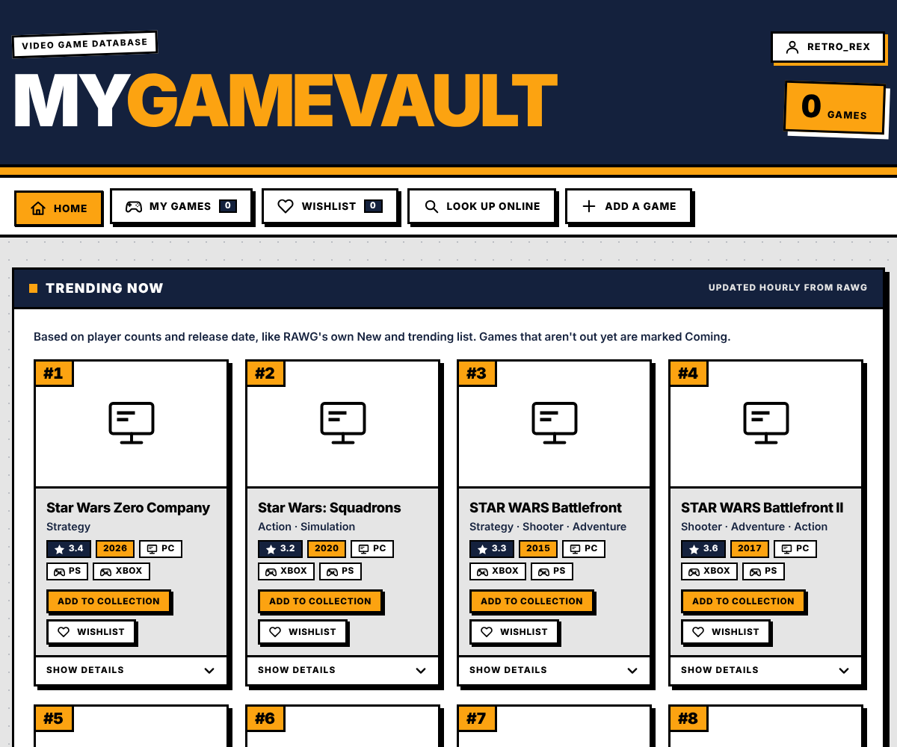
Figure 2. Home view, Trending Now (shown for a player with an empty collection).
Control | What it does
Card #1 to #12 | Rank, cover (or console tile), title, genres, rating, year and platforms. A dark "Coming" tag marks a game that is not out yet.
Add to collection | Saves the game (POST /api/games). The button then reads In collection and cannot be pressed again. A guest is sent to the sign-in form instead.
Wishlist (heart) | Puts the game on the wishlist; it then reads On wishlist, and pressing it again takes the game off. A guest is sent to the sign-in form instead.
Show Details | Opens a drawer with developer, publisher, website, age rating, Metacritic score and average playtime from RAWG.

2. My Games
The signed-in player's collection, newest first, in a two-column grid (a guest sees a prompt to sign in instead). The search box Filter your games narrows the list by title, platform, genre, developer, publisher or year. Each card has Edit (opens the edit page), Delete (asks "Sure?" before it deletes) and Show details. Clicking a title opens the game's details page.
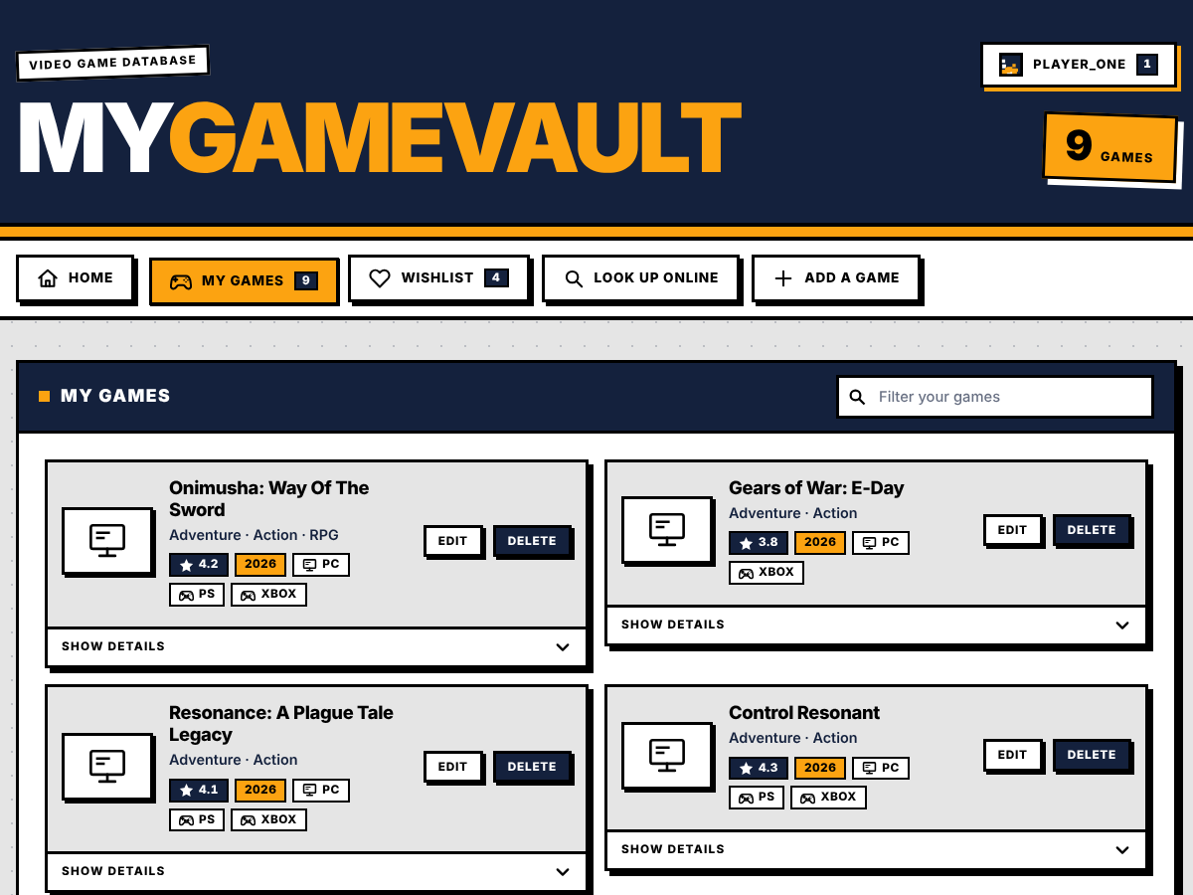
Figure 3. My Games view with the filter box and the Edit and Delete buttons.
Control | What it does
Filter your games | Narrows the list while typing, using title, platform, genre, developer, publisher and year.
Game title | Opens the game's details page with its forum.
Edit | Opens edit.html for that game.
Delete | The first press changes the button to Sure? for four seconds; a second press deletes the game.
Show Details | Opens the drawer. A game added by hand shows a note that it can be completed with Edit.

3. Wishlist
Games the player wants but does not own yet. Move to collection adds the game to My Games and removes it from the wishlist in one step; Remove deletes it from the wishlist.
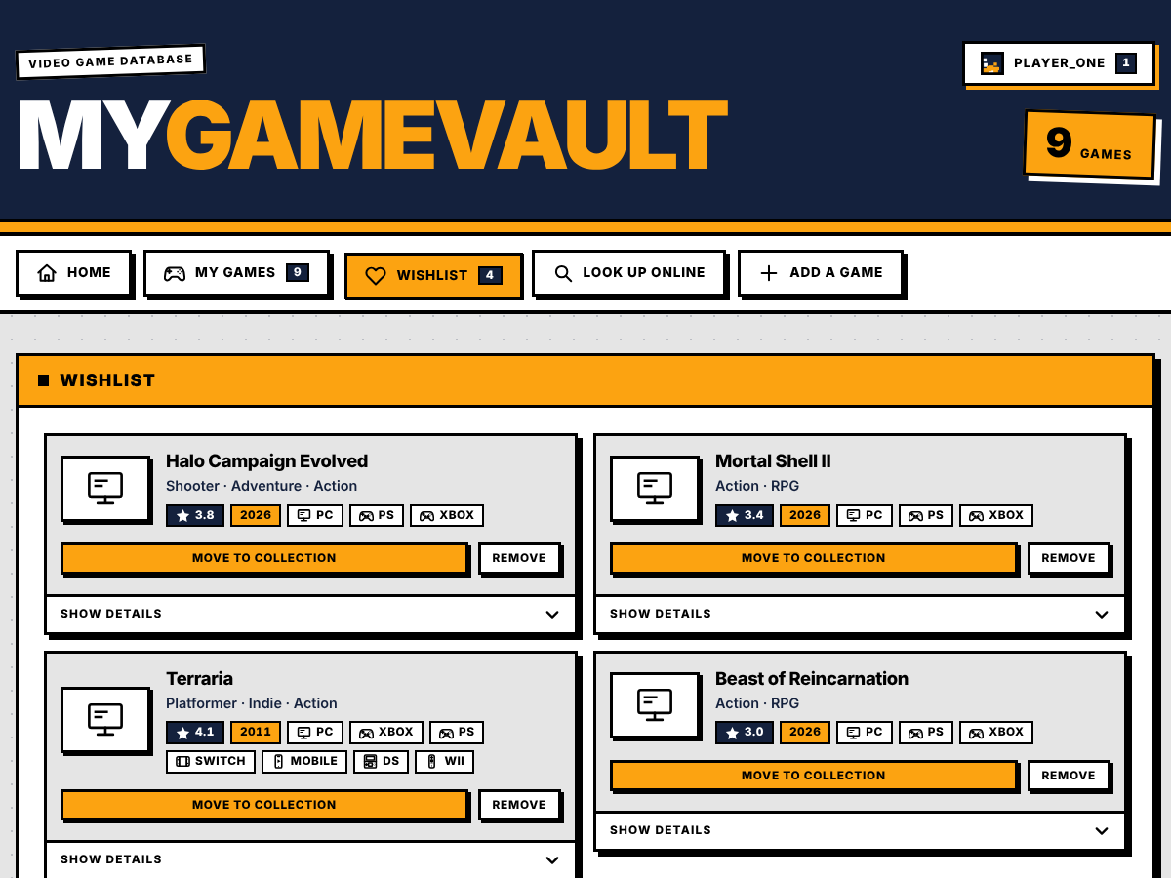
Figure 4. Wishlist view.
Control | What it does
Move to collection | Adds the game to My Games and removes it from the wishlist (POST /api/wishlist/:id/collect).
Remove | Takes the game off the wishlist (DELETE /api/wishlist/:id).
Empty wishlist | Explains that the heart on any game saves it for later, with links to Home and Look Up Online.

4. Look Up Online
Type a title and press Search to ask RAWG. Up to five matches appear, each with its release year, rating, platforms and the buttons Add to collection and Wishlist. A game that is already owned shows a disabled In collection button.
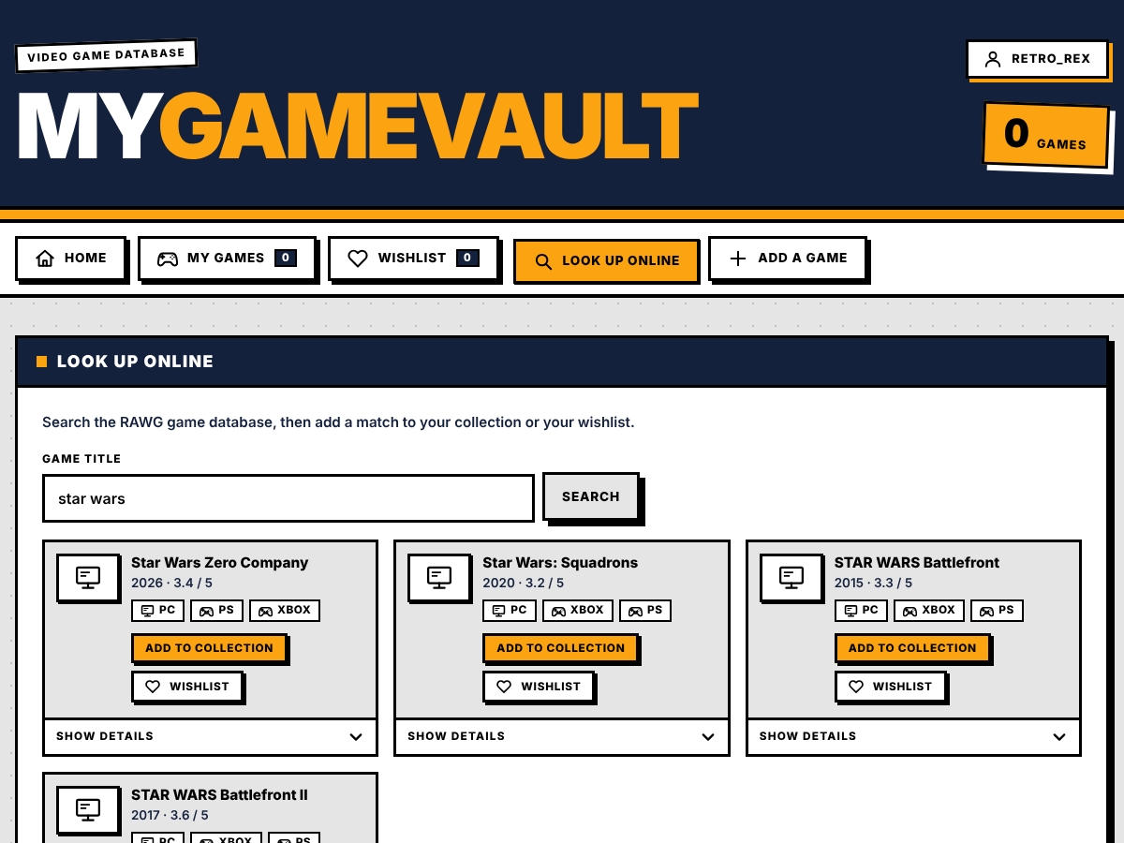
Figure 5. Look Up Online view with search results.
Control | What it does
Game title and Search | Sends the title to GET /api/lookup and shows up to five matches.
Result title | Opens the game's details page.
Add to collection / In collection | Saves the match; the button is disabled once the game is owned.
Wishlist / On wishlist | Adds the match to the wishlist, or removes it again.

5. Add a Game
A form for games that RAWG does not know. Title is required; Developer, Publisher, Rating (0 to 5) and Year are optional, and the platform tiles can be ticked in any combination. Problems are explained in a message above the button. The form is for signed-in members; a guest sees a prompt to sign in instead.
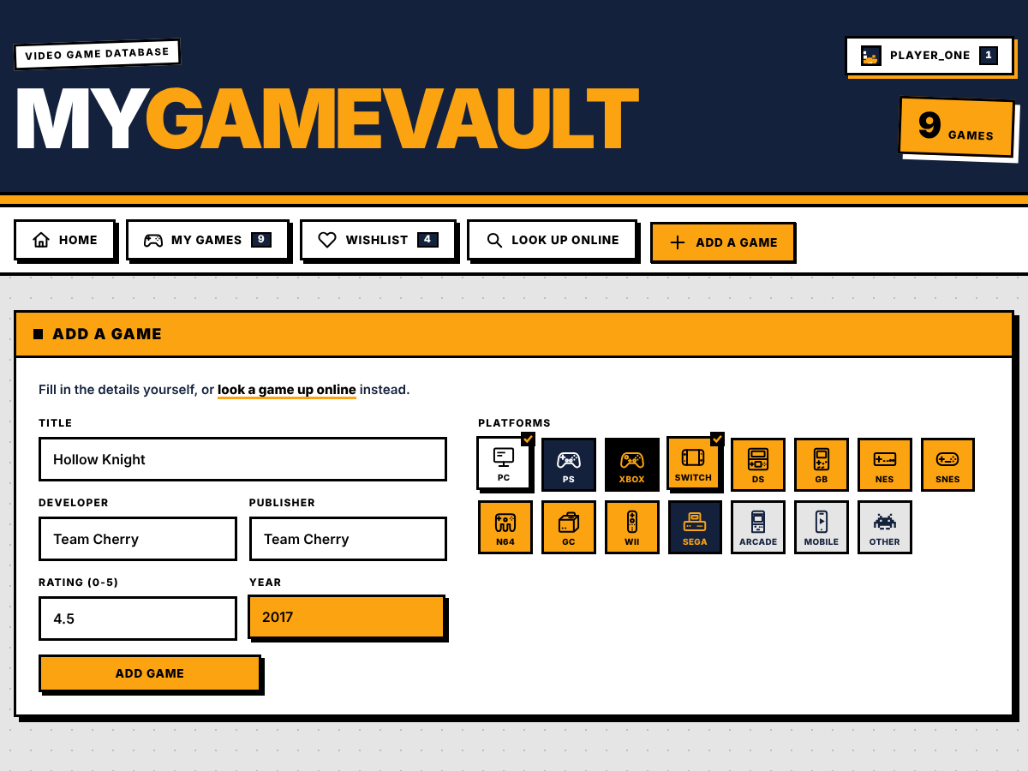
Figure 6. Add a Game form with two platforms ticked.
Control | What it does
Title | Required.
Developer, Publisher | Optional. Several names can be separated with commas.
Rating (0-5) | Optional number with up to two decimals, such as 4.5.
Year | Optional release year from 1 up to next year; it is saved as the game's release date.
Platform tiles | Fifteen tiles; any number can be ticked. They are saved as platform names.
Add game | Saves the game to My Games (POST /api/games). The form is cleared, with the ticked platforms kept, so several games can be entered quickly.

6. Account: sign in and create account
Until someone signs in, the Account tab shows two forms in one card, switched by the Sign in and Create account buttons. Errors such as a taken username or a wrong password appear inside the form.
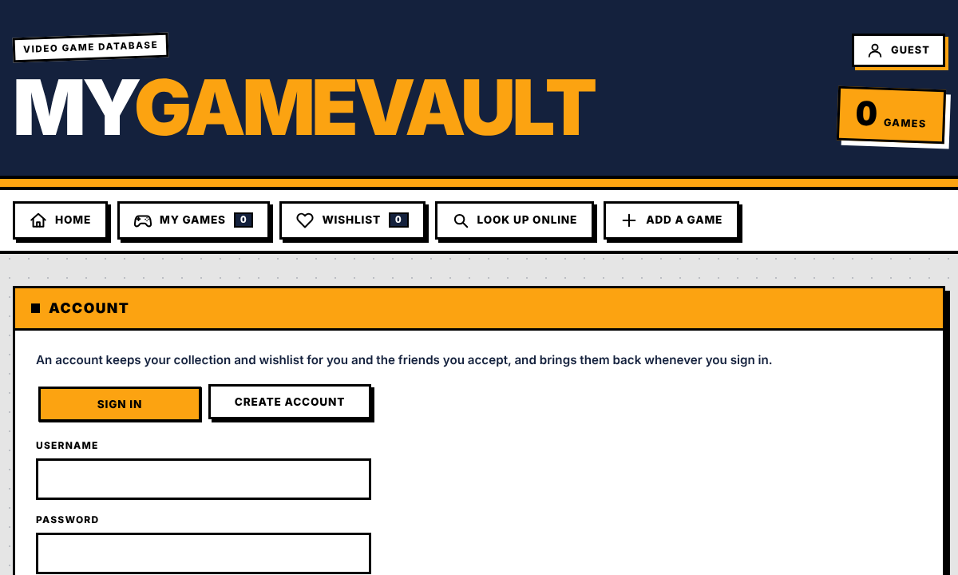  Figure 7. Sign in. | 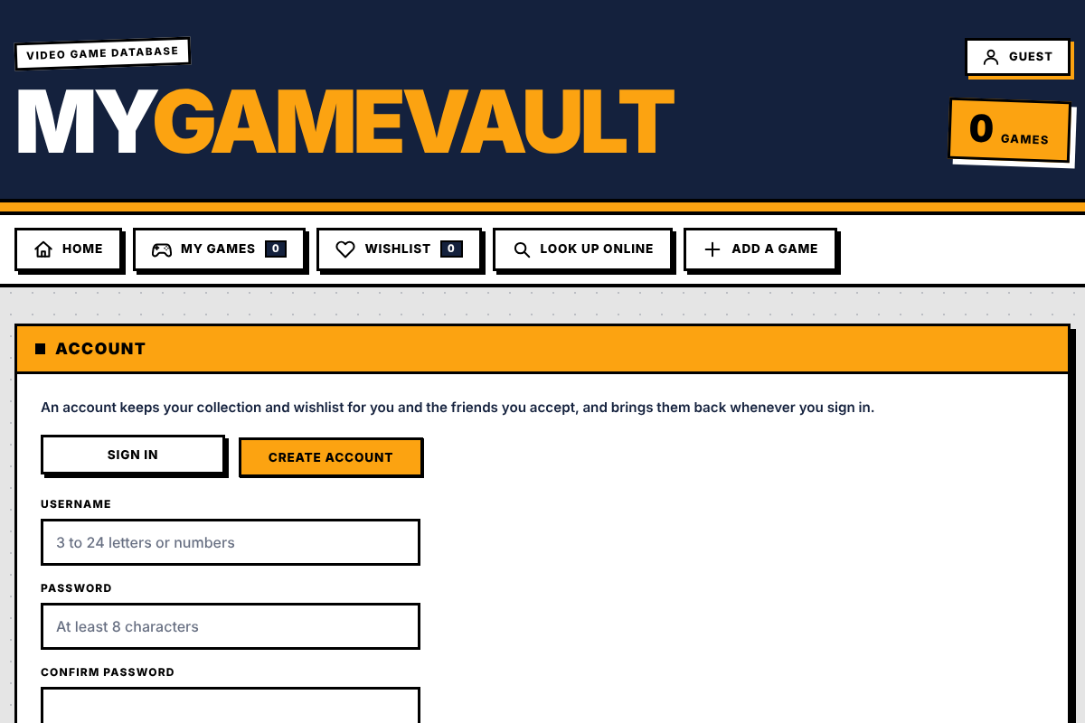  Figure 8. Create account.

Control | What it does
Sign in / Create account | Switches between the two forms.
Username | 3 to 24 letters, numbers, dots, dashes or underscores.
Password | 8 to 128 characters.
Confirm password | Create account only; it must match the password.
Submit button | Calls POST /api/auth/login or POST /api/auth/register. Errors (wrong password, taken username, too many tries) are shown inside the form.

7. Profile (signed in)
Once signed in, the Account tab becomes the player's profile. It has the profile picture with Upload / Change picture and Remove picture (a preview and Save picture appear after choosing a file), four counters (collection, wishlist, friends, member since), the lists Friend requests (Accept / Decline), Friends and Requests you sent (Cancel), the shelves Collection and Wishlist, and the Sign out button.
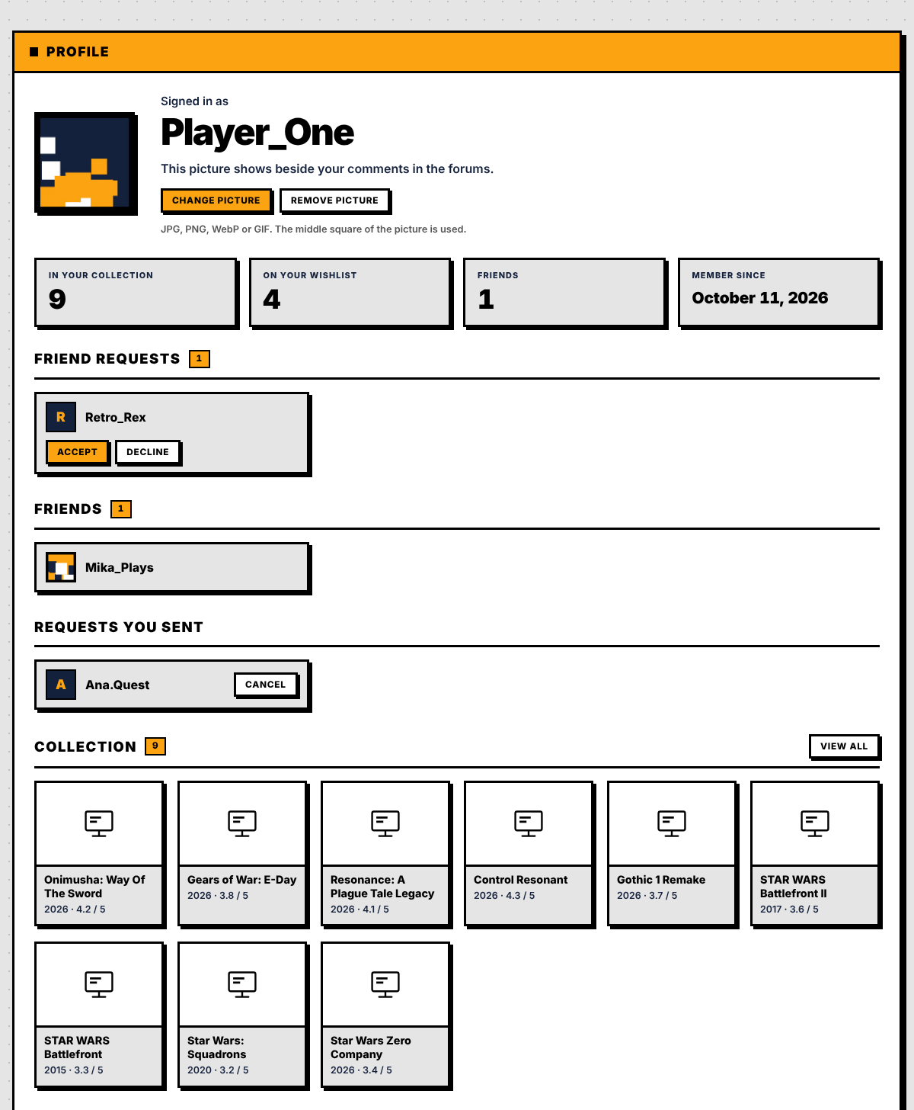
Figure 9. Profile view of a signed-in player.
Control | What it does
Upload picture / Change picture | Chooses an image (JPG, PNG, WebP or GIF up to 15 MB). The middle square is used; Save picture and Cancel appear with a preview.
Remove picture | Deletes the picture; the app then shows the first letter of the username.
Counters | Games in the collection, games on the wishlist, friends, and the member-since date.
Friend requests | People who asked to be friends, with Accept and Decline.
Friends and Requests you sent | Names open the player's page; sent requests have Cancel.
Collection and Wishlist shelves | The twelve newest covers of each; View all opens the full panel.
Sign out | Ends the session (POST /api/auth/logout).

8. Game details and forum
Opening a game shows its page: release date and rating, platforms, genres, developers, publishers and age rating, an expandable System Requirements card, a screenshot gallery with a full-screen viewer, and the stores where the game is sold. At the bottom is the game's Forum: a box to write a comment (1 to 1,000 characters, with a counter), the Newest and Top sorting buttons, and the comments with the author's picture, like and dislike buttons and, for the player's own comments, Delete. Visitors who are not signed in can read the forum and are asked to sign in to post. In this screenshot the screenshot gallery was hidden because the images could not be loaded.
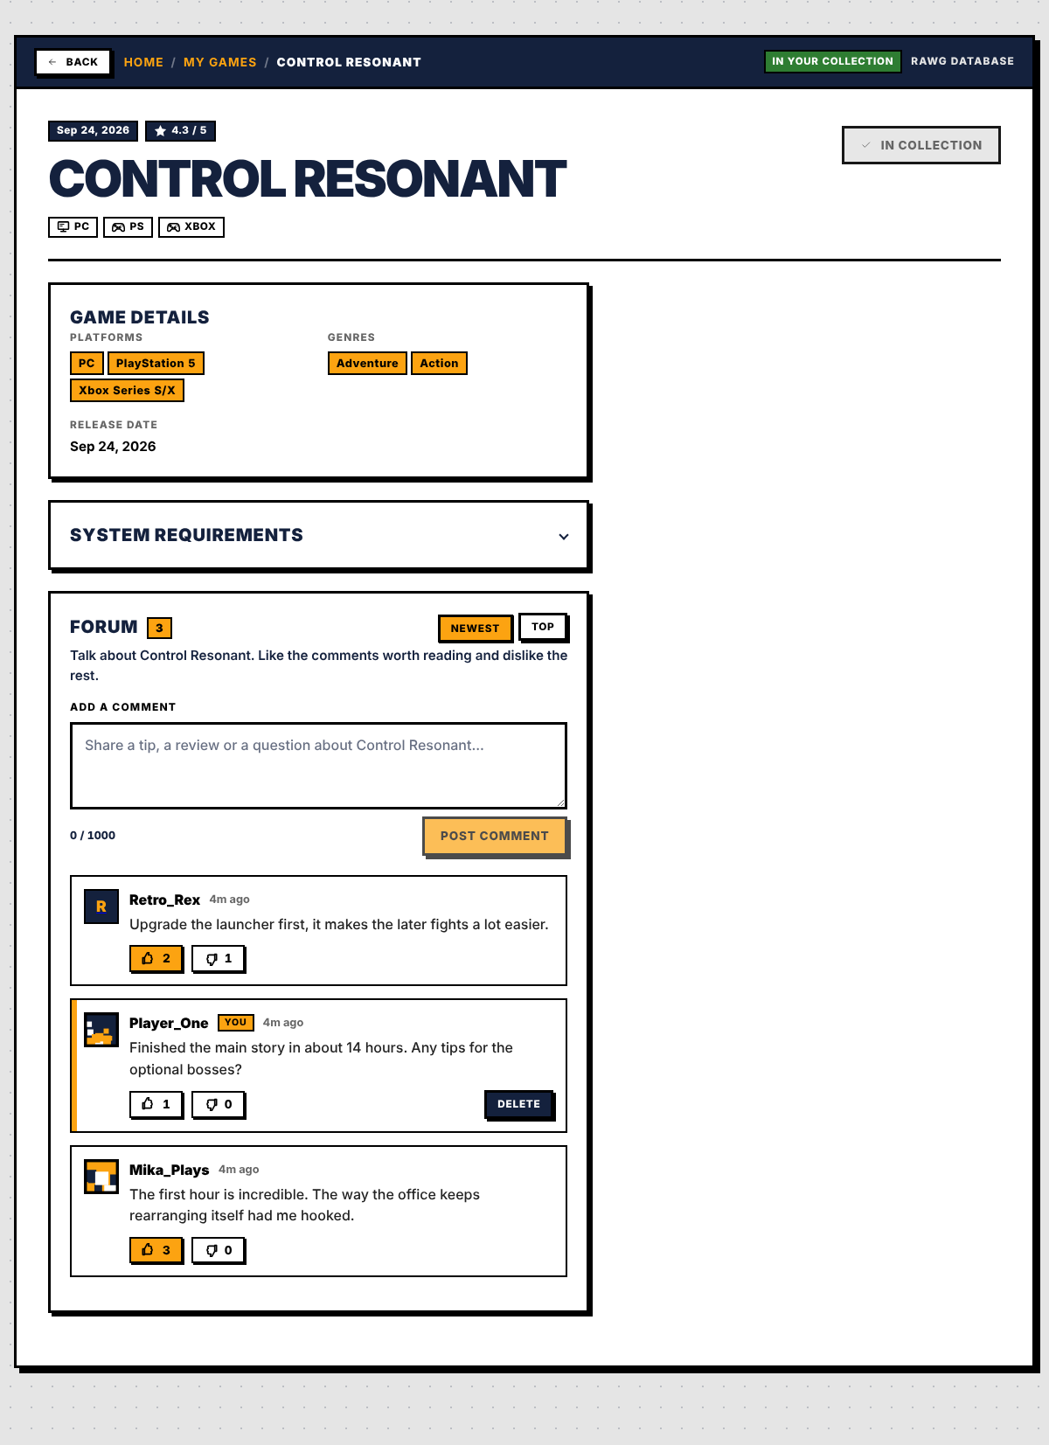
Figure 10. Game details page with the forum.
Control | What it does
Back and the breadcrumb | Return to the view the player came from. Esc also goes back.
Status badges | In your collection or On your wishlist, and the data source (RAWG Database).
Game details card | Platforms, genres, release date, developer, publisher, age rating, website and tags.
System Requirements | Expands to the minimum and recommended requirements that RAWG lists for each platform.
Screenshots | A gallery with Enlarge; the full-screen viewer uses the arrow keys and Esc.
Post comment | Posts to the forum (members only); a counter shows the 1,000-character limit.
Newest / Top | Sorts the comments by date or by likes.
Like and dislike | Sets the player's vote; pressing the same button again clears it.
Show more comments | Reveals the next ten comments.

9. Player profile
Clicking a name in a forum opens that player's page. It shows their picture, member-since date and friend count, and buttons that depend on how the two players stand: Add friend; Request sent with Cancel request; Accept request and Decline; or the Friends badge with Remove friend (it asks "Sure?" first). Their collection and wishlist are shown only to friends; to everyone else the page says what to do to see them.
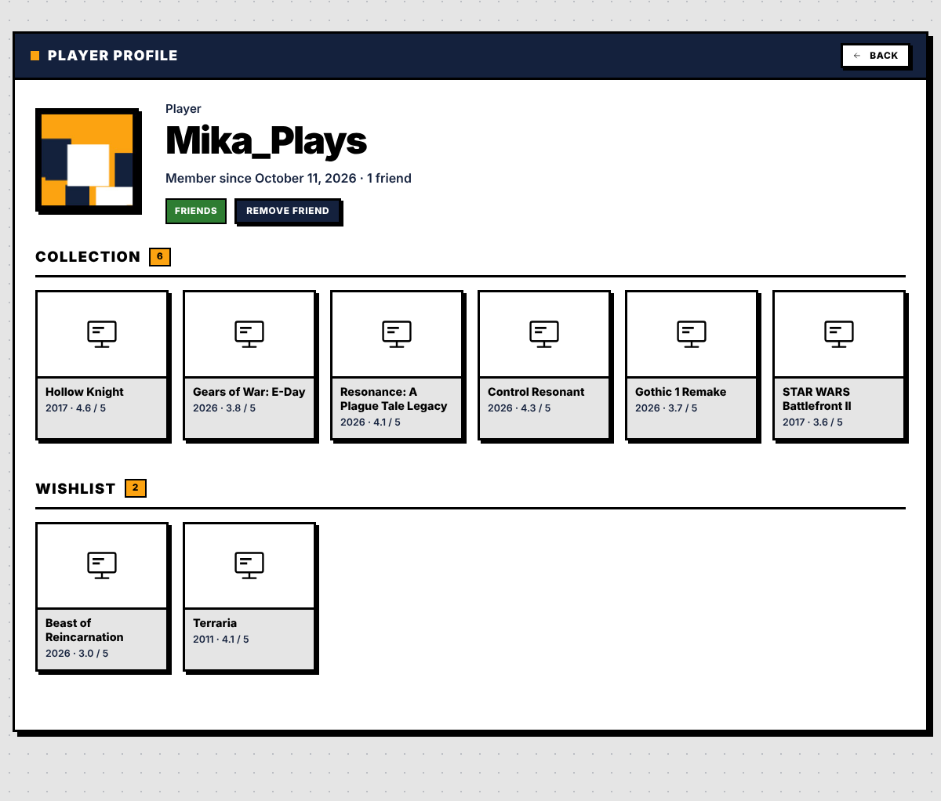
Figure 11. Player profile of a friend, with the collection and wishlist shelves.
Control | What it does
Back | Returns to the page the player was opened from.
Friendship buttons | Add friend, Cancel request, Accept request, Decline or Remove friend, depending on the relation.
Shelves | Covers of the collection and wishlist, with Show more when there are more than twelve.

10. Edit a game
edit.html shows the same fields as the Add a Game form, filled in with the saved values. Save changes sends only what was changed and returns to My Games with a confirmation; Cancel goes back without saving.
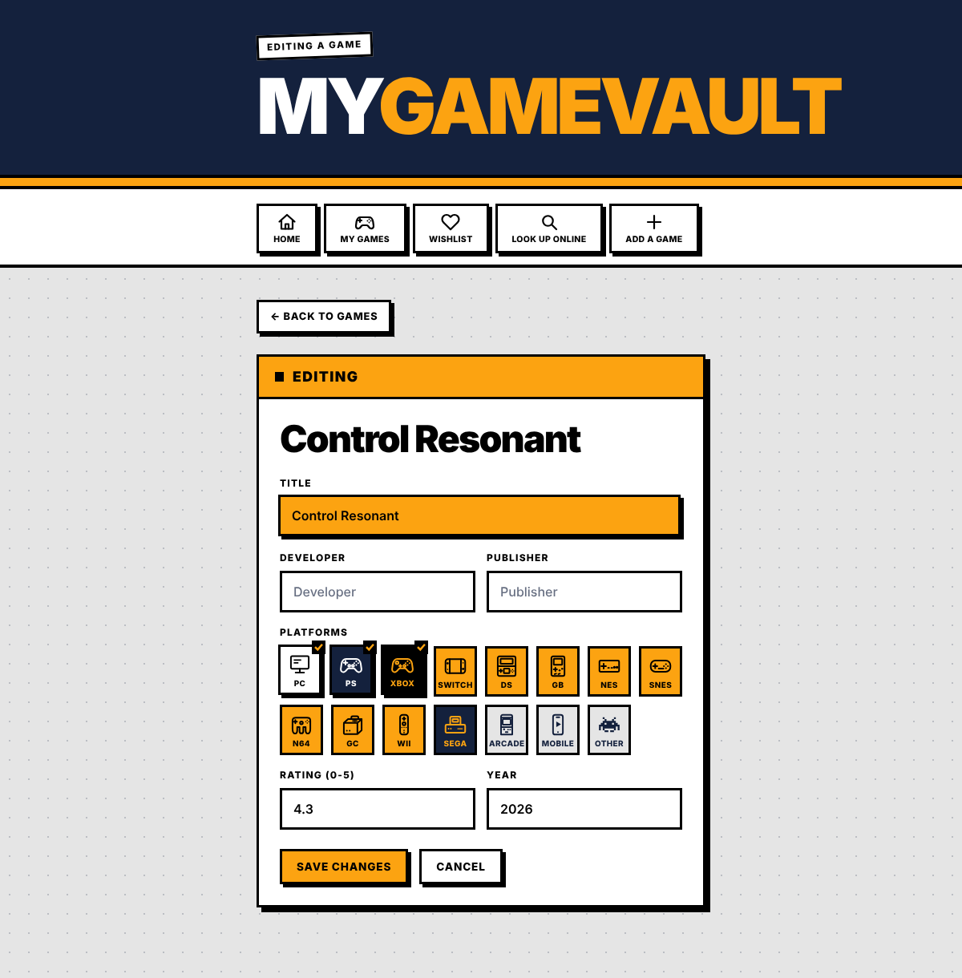
Figure 12. Edit page for a saved game.
Control | What it does
Form fields | Title, developer, publisher, rating, year and the platform tiles, filled in with the saved values.
Save changes | Sends only the fields that changed (PUT /api/games/:id) and returns to My Games.
Cancel, Back to games | Return without saving.
Missing or foreign game | The page explains that the game was not found or asks the visitor to sign in.

IX. Configuration and Source Codes

1. Requirements and how to run
MyGameVault needs Node.js (18 or newer, which Express 5 requires), npm and a free RAWG API key (created at rawg.io/apidocs). Open a terminal in the project folder and run:
- npm install downloads the three dependencies (express, axios and cors).
- Set the environment variables below, at least RAWG_API_KEY.
- npm start runs node server.js (the dev script does the same). The console prints Server running at http://localhost:3000.
- Open http://localhost:3000 in a browser. The server creates its data files on first start.
npm install
RAWG_API_KEY=<your key> npm start # macOS / Linux
$env:RAWG_API_KEY="<your key>"; npm start # Windows PowerShell

2. Configuration
The server reads these environment variables. The project does not load a .env file by itself, so they must be set in the shell (or by the hosting service) before npm start. The file .env.example lists them with example values.
Table 6. Environment variables
Variable | Default | Effect
PORT | 3000 | Port the server listens on (on all interfaces, 0.0.0.0).
RAWG_API_KEY | A key written in server.js | The key sent to RAWG. Set your own; see the limitations at the end of this section.
TRENDING_DAYS | 120 | Size of the date window of the trending fallback query.
DATA_DIR | The project folder | Folder where the JSON files and the avatars folder are kept (created if missing).
COOKIE_SECURE | off | true forces the Secure flag on the session cookie.
NODE_ENV | - | production also forces secure cookies. Secure cookies (with SameSite=None) are used automatically behind HTTPS or on a host other than localhost; otherwise SameSite=Lax.

Table 7. Fixed limits and settings in the code
Setting | Value | Where
Session lifetime | 30 days | auth.js
Password hash | scrypt, N = 2^15, r = 8, p = 1, 16-byte salt | auth.js
Username / password length | 3 to 24 / 8 to 128 characters | auth.js
Login throttle | 8 failures per 10 minutes per IP and username | auth.js
Trending cache | 1 hour; 30 games fetched, 12 shown | server.js
RAWG request timeouts | 8 s (trending, screenshots), 10 s (game details); none on the title search | server.js
Forum comment | 1 to 1,000 characters; 5 per minute; 200 shown | server.js
Profile picture | JPEG, 512 KB, 1,024 pixels per side | profile.js
Profile shelves | 200 games per shelf | profile.js
Pending friend requests | 50 per account | friends.js
Browser request timeout | 20 seconds | public/js/helpers.js

3. Dependencies and scripts
Package | Version | Purpose
express | ^5.2.1 | Web server and routing
axios | ^1.20.0 | Calls to the RAWG API
cors | ^2.8.6 | Cross-origin requests

npm script | Runs | Purpose
npm start, npm run dev | node server.js | Start the server
npm run build | echo 'No build step required' | There is no build step
npm run lint | node --check server.js auth.js db.js friends.js profile.js | Syntax check of the five server files
npm test | node --test "test/**/*.test.js" | Run the automated tests
npm run test:ci | node --test with spec and JUnit reporters | Same tests; also writes test-results/junit.xml for Jenkins

4. Project structure
LibraryWebApp/
|-- server.js Express app: games, wishlist, RAWG lookup and trending, forum routes
|-- auth.js accounts, sessions, guest users and the access guards
|-- friends.js friend requests and friend lists
|-- profile.js profile pictures and player profiles
|-- db.js JSON file storage helpers and the id generator
|-- package.json scripts and dependencies
|-- Dockerfile three-stage image: deps, test, runtime
|-- Jenkinsfile CI pipeline: build, lint, test, build the image
|-- .env.example the environment variables with example values
|-- library.json saved games (data files are created on first start)
|-- wishlist.json wishlisted games
|-- users.json accounts and guests
|-- sessions.json session fingerprints
|-- comments.json forum comments
|-- friends.json friendships
|-- avatars/ profile pictures, one <userId>.jpg each (created on first upload)
|-- jenkins/ a ready-made local Jenkins (Dockerfile, docker-compose.yml, casc.yaml)
|-- test/ automated tests: search, signup, login, collection, forum
`-- public/ everything the browser downloads
|-- index.html, edit.html, style.css, icons.svg, favicon.svg
|-- app.js, platforms.js
`-- js/ helpers, avatar, game-view, game-details, forms, tabs, edit
`-- games/ common, collection, wishlist, browse, account, profile, friends,
person, forum, detail-page, page
Table 8. Frontend files (public folder)
File | Lines | Purpose
index.html | 382 | The single page: masthead, tab bar, every panel, and the script list.
edit.html | 118 | The edit-a-game page.
style.css | 2764 | The neo-brutalist theme and the responsive rules.
icons.svg, favicon.svg | 300 | Icon sprite (interface and console icons) and the site icon.
app.js | 2 | Starts the games page or the edit page, chosen by data-page on <body>.
platforms.js | 25 | The 15 platform tiles and the patterns that map RAWG platform names to them.
js/helpers.js | 108 | el() safe DOM builder, api() fetch wrapper (token, 20 s timeout), toasts, busy buttons.
js/avatar.js | 14 | Profile picture, or a tile with the first letter; versioned picture address.
js/game-view.js | 124 | Shared game helpers: platform tags, year, rating, covers, cards, sameGame, empty states.
js/game-details.js | 129 | The "Show details" drawer; fetches RAWG details once per game and caches them.
js/forms.js | 67 | Platform picker and the validation of the add and edit forms.
js/tabs.js | 65 | Hash-based navigation between the panels and the Back button.
js/edit.js | 74 | Edit page: loads the game and saves only the changes.
js/games/common.js | 131 | Shared store (user, games, wishlist, trending, friends) and shared helpers.
js/games/collection.js | 114 | My Games panel: drawing, filter, delete, details and the Add a Game form.
js/games/wishlist.js | 73 | Wishlist panel: move to collection and remove.
js/games/browse.js | 117 | Home trending grid and the Look Up Online search.
js/games/account.js | 120 | Sign in, create account, sign out and the session.
js/games/profile.js | 186 | Profile: picture crop and upload, counters, collection and wishlist shelves.
js/games/friends.js | 110 | Friend lists and the Accept, Decline and Cancel buttons.
js/games/person.js | 130 | Another player's page and the friendship button.
js/games/forum.js | 281 | The forum: posting, likes and dislikes, delete, sorting, paging.
js/games/detail-page.js | 313 | The game details page: about, details, system requirements, screenshots, stores, forum.
js/games/page.js | 25 | Draws all panels and starts the games page.

5. Automated tests and the Jenkins pipeline
The test folder holds automated tests for the cases of the test plan. npm test runs them with Node's built-in test runner, so no extra package is needed. Every test file starts the app on a random port with an empty temporary data folder (DATA_DIR), and the search tests replace RAWG with a small stand-in, so the tests need neither the internet nor an RAWG key and never touch the real JSON files. A case marked PASSED must succeed; a case marked FAILURE must be refused by the app, so that test is green when the app says no.
Table 9. Automated test cases (test folder)
Test file | Cases | What the test expects
search.test.js | A game that exists; a game that does not exist | Found; nothing found (both answer 200)
signup.test.js | Two matching passwords; two mismatching passwords | Account created (201); refused (400) and no account made
login.test.js | Right username and password; right username, wrong password; wrong username, right password; both wrong | Signed in (200); the other three refused (401)
collection.test.js | A member adds a game to the collection and the wishlist; a guest and a signed-out visitor try the same | Both saved (201); both refused (403) and nothing saved
forum.test.js | A member posts a comment; a signed-out visitor posts one | Posted (201); refused (403)

The Jenkinsfile runs the same tests in Docker, so the Jenkins machine only needs Docker and the JUnit plugin. Its stages are Checkout, Build test image, Lint, Test (which publishes test-results/junit.xml) and Build app image. The Dockerfile builds in three stages: deps (the production packages), test (the app and its tests) and runtime (the app as deployed, run by a non-root user with its data in /data). To run the test stage by hand:
docker build --target test -t librarywebapp-test .
docker run --rm librarywebapp-test

The jenkins folder holds a Jenkins that is already set up with this pipeline. From that folder, docker compose up -d --build starts it at http://localhost:8080 (reachable from this computer only); pressing Build Now on the librarywebapp job then builds what is committed on the main branch.

6. Source code: backend (key functions)
Only the functions that carry the logic of each feature are listed here, with the comments that explain them. The complete files (db.js, auth.js, friends.js, profile.js and server.js) are in the project folder. Every excerpt is copied from the file named above it, and its line numbers are given so it can be found there.
db.js: table, newId
Each JSON file is a table with read() and write(list); a damaged file throws instead of being replaced by an empty list. newId() makes ids that never repeat (Section IV; lines 7–19 and 54–55)
// One JSON file holds one list. A damaged file throws instead of being overwritten with an empty list.
function table(name) {
const file = path.join(DIR, name);
if (!fs.existsSync(file)) fs.writeFileSync(file, "[]", "utf8");
return {
read() {
const list = JSON.parse(fs.readFileSync(file, "utf8") || "[]");
if (!Array.isArray(list)) throw new Error(name + " should hold a list");
return list;
},
write: (list) => fs.writeFileSync(file, JSON.stringify(list, null, 2), "utf8"),
};
}

// The current time in milliseconds, moved past the highest id in the list so ids never repeat
exports.newId = (list) => list.reduce((next, item) => Math.max(next, Number(item.id) + 1 || 0), Date.now());
auth.js: hashPassword, checkPassword
Passwords are stored as scrypt$N$r$p$salt$hash and compared in constant time; the decoy hash makes an unknown username take as long as a wrong password (Section V.6; lines 12–30)
// Passwords are stored as "scrypt$N$r$p$salt$hash", never as themselves
const derive = (password, salt, { N, r, p }, length) => scrypt(password, salt, length, { N, r, p, maxmem: 256 * N * r });

async function hashPassword(password) {
const salt = crypto.randomBytes(16);
const hash = await derive(password, salt, COST, 64);
return ["scrypt", COST.N, COST.r, COST.p, salt.toString("hex"), hash.toString("hex")].join("$");
}

async function checkPassword(password, stored) {
const [scheme, N, r, p, salt, hash] = String(stored).split("$");
if (scheme !== "scrypt" || !hash) return false;
const expected = Buffer.from(hash, "hex");
const actual = await derive(password, Buffer.from(salt, "hex"), { N: +N, r: +r, p: +p }, expected.length);
return crypto.timingSafeEqual(actual, expected);
}

// Checked when the username does not exist, so the answer takes as long and gives nothing away
const decoy = hashPassword("no account uses this password");
auth.js: fingerprint, currentUser, requireAuth, requireMember
Only a SHA-256 fingerprint of the session token is stored. requireAuth gives a visitor without a session a guest account; requireMember refuses guests with a 403 (Sections V.1 and V.6; lines 58–59, 93–99 and 109–123)
// Only a SHA-256 fingerprint of each token is stored, so a leaked sessions.json signs nobody in
const fingerprint = (token) => crypto.createHash("sha256").update(token).digest("hex");

function currentUser(req) {
const token = readToken(req);
if (!token) return null;
const print = fingerprint(token);
const session = db.sessions.read().find((s) => s.token === print && s.expires > Date.now());
return session ? db.users.read().find((u) => u.id === session.userId) || null : null;
}

function requireAuth(req, res, next) {
req.user = currentUser(req) || newGuest(req, res).user;
res.set("Cache-Control", "no-store");
next();
}

// For things only a real account can do. Guests and signed-out visitors get a 403, not a 401,
// so the page does not think a sign-in has ended.
const requireMember = (action = "do that") => (req, res, next) => {
const user = currentUser(req);
if (!user || user.isGuest) return res.status(403).json({ error: "Sign in or create an account to " + action + "." });
req.user = user;
res.set("Cache-Control", "no-store");
next();
};
auth.js: POST /api/auth/login
The sign-in route. After 8 wrong passwords in 10 minutes for the same address and username it answers 429 (Section V.6; lines 40–43 and 166–187)
// Wrong passwords per "ip|username". After 8 within 10 minutes, logins for it are refused for a while.
const failed = new Map();
const MAX_TRIES = 8;
const TRY_WINDOW_MS = 10 * 60 * 1000;

router.post("/login", async (req, res) => {
const { username, password } = req.body ?? {};
if (typeof username !== "string" || typeof password !== "string" || !username.trim() || !password) {
return res.status(400).json({ error: "Enter your username and password." });
}
const key = username.trim().toLowerCase();
const who = req.ip + "|" + key;
if ((tries(who)?.count ?? 0) >= MAX_TRIES) {
res.set("Retry-After", String(TRY_WINDOW_MS / 1000));
return res.status(429).json({ error: "Too many tries. Wait a few minutes, then try again." });
}

const user = db.users.read().find((u) => u.key === key);
const right = password.length <= 128 && (await checkPassword(password, user ? user.passwordHash : await decoy));
if (!user || !right) {
noteFailure(who);
return res.status(401).json({ error: "Wrong username or password." });
}
failed.delete(who);
adoptSavedGames(user);
res.json({ user: publicUser(user), token: startSession(req, res, user) });
});
server.js: sameGame, addGame, POST /api/games
Two records are the same game when the RAWG id or the title matches. Every new game is stamped with the caller's userId and leaves the wishlist (Section V.4; lines 22–26, 30–36 and 48–55)
const mine = (req) => (item) => item.userId === req.user.id;
const mineWithId = (req) => (item) => item.userId === req.user.id && String(item.id) === String(req.params.id);
// Two records are the same game when they share a RAWG id or a title (ignoring case and spaces)
const titleKey = (game) => String(game.title ?? "").trim().toLowerCase();
const sameGame = (a, b) => Boolean((a.rawg_id && a.rawg_id === b.rawg_id) || (titleKey(a) && titleKey(a) === titleKey(b)));

// Adds a game to the caller's collection; any id or userId the client sent is ignored
function addGame(req, { id, userId, addedAt, ...fields }) {
const games = db.games.read();
const game = { id: db.newId(games), ...fields, userId: req.user.id };
db.games.write([...games, game]);
return game;
}

app.post("/api/games", auth.requireMember("add games to your collection"), (req, res) => {
const game = addGame(req, req.body ?? {});
// A game that is now owned leaves the wishlist
const wishlist = db.wishlist.read();
const rest = wishlist.filter((item) => !(mine(req)(item) && sameGame(item, game)));
if (rest.length !== wishlist.length) db.wishlist.write(rest);
res.status(201).json(game);
});
server.js: POST /api/wishlist, POST /api/wishlist/:id/collect
Wishlisting a game that is already owned or already wished is refused with 409; collect moves an entry into the collection, 201 for a new game and 200 for one already owned (Section V.4; lines 74–90 and 97–106)
app.post("/api/wishlist", auth.requireMember("keep a wishlist"), (req, res) => {
const body = req.body ?? {};
if (typeof body.title !== "string" || !body.title.trim()) return res.status(400).json({ error: "A game needs a title" });
const fields = Object.fromEntries(WISH_FIELDS.filter((key) => body[key] !== undefined).map((key) => [key, body[key]]));
fields.title = body.title.trim();

if (db.games.read().some((g) => mine(req)(g) && sameGame(g, fields))) {
return res.status(409).json({ error: "That game is already in your collection." });
}
const wishlist = db.wishlist.read();
if (wishlist.some((item) => mine(req)(item) && sameGame(item, fields))) {
return res.status(409).json({ error: "That game is already on your wishlist." });
}
const item = { id: db.newId(wishlist), ...fields, userId: req.user.id, addedAt: new Date().toISOString() };
db.wishlist.write([...wishlist, item]);
res.status(201).json(item);
});

// Moves a wishlist entry into the collection: 201 when it was added, 200 when the game was already owned
app.post("/api/wishlist/:id/collect", auth.requireMember("add games to your collection"), (req, res) => {
const wishlist = db.wishlist.read();
const item = wishlist.find(mineWithId(req));
if (!item) return res.status(404).json({ error: "Wishlist entry not found" });
const owned = db.games.read().find((g) => mine(req)(g) && sameGame(g, item));
const game = owned || addGame(req, item);
db.wishlist.write(wishlist.filter((w) => w !== item));
res.status(owned ? 200 : 201).json(game);
});
server.js: summarize, GET /api/lookup
Look Up Online asks RAWG for five matches and reduces each one to the fields the app stores (Section V.2; lines 110–125)
const names = (list) => (list || []).map((entry) => entry.name);
const summarize = (game) => ({
rawg_id: game.id,
title: game.name,
released: game.released || "N/A",
rating: game.rating || "N/A",
image: game.background_image || null,
platforms: (game.platforms || []).map((p) => p.platform.name),
genres: names(game.genres),
});

app.get("/api/lookup", async (req, res) => {
if (!req.query.title) return res.status(400).json({ error: "Title query parameter is required" });
const data = await rawg("games", { search: req.query.title, page_size: 5 });
res.json(data.results.map(summarize));
});
server.js: adultOnly, refreshTrending, GET /api/trending
The trending list is cached for an hour, shared by visitors who ask at the same moment, stripped of adult-only games, and the older list is served if RAWG fails; fetchTrending, not shown, asks RAWG for its "New and trending" list and falls back to recent games by popularity (Section V.3; lines 186–190, 192–195 and 212–234)
const TRENDING_SIZE = 12;
const TRENDING_FETCH = 30; // more than are shown, because repeats and adult-only games are dropped
const TRENDING_TTL = 60 * 60 * 1000;
let trending = { at: 0, games: [] };
let refreshing = null;

// Mainstream mature games carry tags like "Nudity", so only these tags (or an AO rating) count as adult-only
const ADULT_ONLY_TAGS = new Set(["hentai", "nsfw", "erotic", "eroge", "porn"]);
const adultOnly = (game) =>
game.esrb_rating?.slug === "adults-only" || (game.tags ?? []).some((tag) => ADULT_ONLY_TAGS.has(tag.slug));

// Visitors who ask at the same moment share one RAWG call
function refreshTrending() {
refreshing ??= fetchTrending()
.then((results) => {
const seen = new Set();
const games = results.filter((game) => !seen.has(game.id) && seen.add(game.id) && !adultOnly(game));
trending = { at: Date.now(), games: games.slice(0, TRENDING_SIZE).map(summarize) };
})
.finally(() => { refreshing = null; });
return refreshing;
}

app.get("/api/trending", async (req, res) => {
try {
if (Date.now() - trending.at > TRENDING_TTL) await refreshTrending();
} catch (error) {
if (!trending.games.length) throw error;
// RAWG failed but an older list exists: serve it, and try RAWG again in a minute
console.error("RAWG Trending Error:", error.response?.data || error.message);
trending.at = Date.now() - TRENDING_TTL + 60 * 1000;
}
res.json(trending.games);
});
server.js: forumKey, POST comment, POST vote
A thread is named rawg-<id> or title-<title>; a member may post 5 comments a minute; a vote is set, never toggled, so a double click or a retry cannot flip it (Section V.7; lines 238–241, 243–249, 278–294 and 296–308)
const FORUM_MAX_LENGTH = 1000;
const FORUM_MAX_SHOWN = 200;
const FORUM_BURST = { count: 5, windowMs: 60 * 1000 };
const requireMember = auth.requireMember("join the forum");

// A thread is "rawg-<id>", or "title-<lower-case title>" for a game added by hand
function forumKey(raw) {
const key = String(raw ?? "").trim();
if (/^rawg-\d{1,9}$/.test(key)) return key;
const title = key.startsWith("title-") && key.slice(6).toLowerCase().replace(/\s+/g, " ").trim().slice(0, 120);
return title && !/[\u0000-\u001f]/.test(title) ? "title-" + title : null;
}

app.post("/api/forum/:key/comments", requireMember, (req, res) => {
const key = forumKey(req.params.key);
if (!key) return res.status(400).json({ error: "That game has no forum." });
const text = typeof req.body?.body === "string" ? req.body.body.replace(/\r\n?/g, "\n").replace(/\n{3,}/g, "\n\n").trim() : "";
if (!text) return res.status(400).json({ error: "Write something before you post." });
if (text.length > FORUM_MAX_LENGTH) return res.status(400).json({ error: "Comments can be up to " + FORUM_MAX_LENGTH + " characters." });

const comments = db.comments.read();
const since = Date.now() - FORUM_BURST.windowMs;
if (comments.filter((c) => c.userId === req.user.id && Date.parse(c.createdAt) > since).length >= FORUM_BURST.count) {
return res.status(429).json({ error: "You're posting fast. Wait a minute, then try again." });
}
const comment = { id: db.newId(comments), gameKey: key, userId: req.user.id, username: req.user.username,
body: text, createdAt: new Date().toISOString(), votes: {} };
db.comments.write([...comments, comment]);
res.status(201).json(forumView(comment, req.user));
});

// Sets (never toggles) a vote, so a double click or a retry cannot flip it: 1 likes, -1 dislikes, 0 clears
app.post("/api/forum/comments/:id/vote", requireMember, (req, res) => {
const value = req.body?.value;
if (![1, -1, 0].includes(value)) return res.status(400).json({ error: "A vote is 1 (like), -1 (dislike) or 0 (clear)." });
const comments = db.comments.read();
const comment = comments.find((c) => String(c.id) === String(req.params.id));
if (!comment) return res.status(404).json({ error: "That comment is gone." });
comment.votes ??= {};
if (value === 0) delete comment.votes[req.user.id];
else comment.votes[req.user.id] = value;
db.comments.write(comments);
res.json(forumView(comment, req.user));
});
server.js: error handler
Express 5 passes every error a route throws or rejects to this handler, so the routes have no try/catch of their own (Section V.1; lines 315–322)
// Express 5 sends every thrown or rejected error here, so the routes need no try/catch of their own
app.use((error, req, res, next) => {
if (error.type === "entity.too.large") return res.status(413).json({ error: "That picture is too big. The limit is 512 KB." });
if (error.expose) return res.status(error.status).json({ error: error.message }); // a request body that can't be read
console.error(req.method + " " + req.path + ":", error.response?.data || error);
if (error.response?.status === 404) return res.status(404).json({ error: "Game not found on RAWG" });
res.status(500).json({ error: error.isAxiosError ? "Failed to fetch games from the RAWG service" : "Something went wrong on the server" });
});
friends.js: relation, POST /api/friends/:username
relation() works out how two players stand; the route sends a request or accepts one that is already waiting, and asking twice changes nothing (Section V.9; lines 7, 16–25 and 48–70)
const MAX_WAITING = 50; // requests one account can have waiting for an answer at once

const between = (links, a, b) => links.find((l) => (l.from === a && l.to === b) || (l.from === b && l.to === a));

// How the viewer stands with the other player: "friends", "requested" (the viewer asked),
// "incoming" (the other one asked) or "none"
function relation(links, viewerId, otherId) {
const link = between(links, viewerId, otherId);
if (!link) return "none";
if (link.status === "accepted") return "friends";
return link.from === viewerId ? "requested" : "incoming";
}

// Add someone: asks them, or accepts if they have already asked you. Asking twice changes nothing.
router.post("/:username", (req, res) => {
const other = findPerson(req.params.username);
if (!other) return res.status(404).json({ error: "No one has that username." });
const me = req.user.id;
if (other.id === me) return res.status(400).json({ error: "You can't add yourself." });

const links = db.friends.read();
const link = between(links, me, other.id);
if (!link) {
if (links.filter((l) => l.from === me && l.status === "pending").length >= MAX_WAITING) {
return res.status(429).json({ error: "You have " + MAX_WAITING + " requests waiting. Wait for some answers first." });
}
links.push({ id: db.newId(links), from: me, to: other.id, status: "pending", createdAt: new Date().toISOString() });
db.friends.write(links);
return res.status(201).json({ relation: "requested" });
}
if (link.status === "pending" && link.to === me) {
Object.assign(link, { status: "accepted", acceptedAt: new Date().toISOString() });
db.friends.write(links);
}
res.json({ relation: link.status === "accepted" ? "friends" : "requested" });
});
profile.js: jpegSize, GET /api/profile/:username
jpegSize() reads the picture size from the JPEG header, so a small file that claims to be huge is refused; a profile shows the collection and wishlist only to friends and to the owner (Sections V.8 and V.9; lines 14–35 and 65–82)
// Width and height from a JPEG's frame header, or null if the bytes are not a JPEG with one. A picture
// claiming to be huge can fit in a small file and use gigabytes in every browser that draws it.
function jpegSize(bytes) {
if (bytes.length < 4 || bytes[0] !== 0xff || bytes[1] !== 0xd8) return null;
let at = 2;
while (at + 4 <= bytes.length) {
if (bytes[at] !== 0xff) return null;
const marker = bytes[at + 1];
if (marker === 0xff) { at++; continue; }
// Markers with no length: TEM, the restart markers and a repeated start of image
if (marker === 0x01 || marker === 0xd8 || (marker >= 0xd0 && marker <= 0xd7)) { at += 2; continue; }
if (marker === 0xd9 || marker === 0xda) return null; // the image ended, or the scan began, with no frame header
const length = bytes.readUInt16BE(at + 2);
if (length < 2) return null;
if (marker >= 0xc0 && marker <= 0xcf && ![0xc4, 0xc8, 0xcc].includes(marker)) {
if (length < 8 || at + 9 > bytes.length) return null;
return { height: bytes.readUInt16BE(at + 5), width: bytes.readUInt16BE(at + 7) };
}
at += 2 + length;
}
return null;
}

// Any member can see who a player is and how they stand with them. The collection and wishlist
// only go to friends, and to the owner.
router.get("/:username", auth.requireMember("view profiles"), (req, res) => {
const person = findPerson(req.params.username);
if (!person) return res.status(404).json({ error: "No one has that username." });
const links = db.friends.read();
const relation = person.id === req.user.id ? "self" : friends.relation(links, req.user.id, person.id);
const open = relation === "self" || relation === "friends";
res.json({
username: person.username,
avatarAt: person.avatarAt ?? null,
createdAt: person.createdAt,
relation,
friendCount: friends.friendCount(links, person.id),
collection: open ? shelf(db.games.read(), person.id) : null,
wishlist: open ? shelf(db.wishlist.read(), person.id) : null,
});
});

7. Source code: frontend (key functions)
The browser code is plain JavaScript without a framework; index.html loads the files in the order of Table 8, so the functions below can call each other. The functions shown are the ones behind the features of Section V. The other frontend files only draw the views and are in the project folder.
public/js/helpers.js: el, api
el() writes text with textContent, so RAWG or player text is never run as HTML; api() sends JSON with the saved session token and gives up after 20 seconds (Section V.1; lines 5–17 and 39–60)
// Builds an element. Text goes in as textContent, never as HTML, so data from RAWG or players can't inject markup.
function el(tag, props = {}, ...children) {
const node = document.createElement(tag);
for (const [key, value] of Object.entries(props)) {
if (key === "class") node.className = value;
else if (key === "text") node.textContent = value;
else if (key.startsWith("on") && typeof value === "function") node.addEventListener(key.slice(2).toLowerCase(), value);
else if (key in node && typeof value !== "string" && typeof value !== "number") node[key] = value;
else node.setAttribute(key, value);
}
node.append(...children.filter((child) => child != null && child !== false));
return node;
}

// Calls the server with JSON (or a picture) and the saved session token, and gives up after 20 seconds
async function api(path, { method = "GET", body } = {}) {
const headers = {};
if (body) headers["Content-Type"] = body instanceof Blob ? body.type || "application/octet-stream" : "application/json";
const token = tryStorage("localStorage", "getItem", "mgv_token");
if (token) headers["x-session-token"] = token;

let res;
try {
res = await fetch(path, { method, headers, body: body instanceof Blob ? body : body && JSON.stringify(body), signal: AbortSignal.timeout(20000) });
} catch (err) {
throw new Error(err.name === "TimeoutError" ? "The server took too long to answer. Try again." : "Can't reach the server. Is it running?");
}
const data = await res.json().catch(() => ({}));
if (data?.token) tryStorage("localStorage", "setItem", "mgv_token", data.token);
if (res.ok) return data;
if (res.status === 401 && !path.startsWith("/api/auth/")) {
tryStorage("localStorage", "removeItem", "mgv_token");
window.dispatchEvent(new Event("session-ended"));
}
throw Object.assign(new Error(data.error || "Something went wrong (" + res.status + ")."), { status: res.status });
}
public/platforms.js: platformFor
Maps a RAWG platform name such as "PlayStation 5" to one of the fifteen console tiles by the patterns in PLATFORMS (Section III; lines 22–25)
function platformFor(name) {
const text = String(name ?? "").trim();
return PLATFORMS.find((p) => p.match && p.match.test(text)) || null;
}
public/js/game-view.js: sameGame
The same rule as on the server, so a card can read In collection or On wishlist (Section V.4; lines 30–31)
const titleKey = (game) => String(game.title ?? "").trim().toLowerCase();
const sameGame = (a, b) => Boolean((a.rawg_id && a.rawg_id === b.rawg_id) || (titleKey(a) && titleKey(a) === titleKey(b)));
public/js/games/collection.js: visibleGames, collect
Filter your games runs in the browser on the list that is already loaded; collect() shows a game the server has just saved and takes it off the wishlist (Sections V.4 and V.5; lines 25–37 and 71–79)
// "Filter your games" looks in the title, platforms, genres, developers, publishers and year. Newest first.
function visibleGames() {
const q = store.filter.trim().toLowerCase();
return [...store.games].sort((a, b) => b.id - a.id).filter((g) => [
g.title,
platformNames(g).join(" "),
platformTags(g).map((t) => t.title).join(" "),
genresOf(g).join(" "),
listOf(g.developers).join(" "),
listOf(g.publishers).join(" "),
yearOf(g),
].join(" ").toLowerCase().includes(q));
}

// Shows a game the server has just put in the collection (it leaves the wishlist at the same time)
function collect(game, message = "Added “" + (game.title || "Untitled game") + "” to your collection.") {
store.games = [...store.games.filter((g) => g.id !== game.id), game];
store.wishlist = store.wishlist.filter((item) => !sameGame(item, game));
renderAll();
const card = $("games").querySelector('[data-id="' + game.id + '"]');
if (card) slamIn(card);
toast(message);
}
public/js/forms.js: readForm
Checks the Add a Game and Edit forms before anything is sent (Section V.4; lines 20–42)
// Checks the add or edit form: { values } when it is fine, { error, field } when it is not
function readForm(form) {
const title = form.elements.title.value.trim();
const rating = form.elements.rating.value.trim();
const year = form.elements.year.value.trim();
if (!title) return { error: "Give the game a title.", field: "title" };
if (rating && (!/^\d(\.\d{1,2})?$/.test(rating) || Number(rating) > 5)) {
return { error: "Rating should be a number from 0 to 5, like 4.5.", field: "rating" };
}
if (year && (!/^\d{1,4}$/.test(year) || Number(year) < 1 || Number(year) > MAX_YEAR)) {
return { error: "Year should be a number between 1 and " + MAX_YEAR + ".", field: "year" };
}
return {
values: {
title,
platformIds: [...form.querySelectorAll("input[name=platform]:checked")].map((box) => box.value),
rating: rating ? Number(rating) : null,
year: year ? Number(year) : null,
developers: listOf(form.elements.developer.value),
publishers: listOf(form.elements.publisher.value),
},
};
}
public/js/edit.js: platformsAfterEdit, edit submit
Only the fields that changed are sent with PUT /api/games/:id, and platform names the tiles do not cover are kept (Section V.4; lines 1–7 and 46–71)
// The new platform list: names the tiles don't cover are kept, unticked tiles are dropped, new tiles are added
function platformsAfterEdit(game, ids) {
const names = platformNames(game);
const keep = names.filter((name) => !platformFor(name) || ids.includes(platformFor(name).id));
const had = new Set(names.map((name) => platformFor(name)?.id));
return [...keep, ...ids.filter((id) => !had.has(id)).map((id) => platformById(id).name)];
}

// Only the fields that changed are sent, so RAWG details the form doesn't show are kept
onSubmit(form, async () => {
const check = readForm(form);
if (check.error) return showFormError(form, check.error, check.field);
const { title, platformIds, rating, year, developers, publishers } = check.values;
const changes = { title };
const before = knownPlatformIds(original);
if (before.length !== platformIds.length || !platformIds.every((pid) => before.includes(pid))) {
changes.platforms = platformsAfterEdit(original, platformIds);
}
if (rating !== ratingOf(original)) changes.rating = rating;
if (year !== yearOf(original)) changes.released = year == null ? null : String(year);
if (!sameList(developers, listOf(original.developers))) changes.developers = developers;
if (!sameList(publishers, listOf(original.publishers))) changes.publishers = publishers;

const button = form.querySelector("button[type=submit]");
setBusy(button, true, "Saving");
try {
const game = await api("/api/games/" + encodeURIComponent(id), { method: "PUT", body: changes });
setFlash("Saved changes to “" + (game.title || "Untitled game") + "”.");
window.location.href = "index.html#collection";
} catch (err) {
setBusy(button, false);
showFormError(form, err.message);
}
});
public/js/games/profile.js: pictureToJpeg
Crops the middle square, shrinks it to 256 pixels and encodes a JPEG, the only format the server accepts (Section V.8; lines 16–42)
// Crops the middle square, shrinks it to 256 pixels and encodes a JPEG, which is all the server takes.
// Redrawing the picture also drops whatever the file carried, such as where a photo was taken.
async function pictureToJpeg(file) {
if (!file.type.startsWith("image/")) throw new Error("That isn't a picture. Pick a JPG, PNG, WebP or GIF.");
if (file.size > PICTURE_MAX_FILE) throw new Error("That picture is over 15 MB. Pick a smaller one.");
const url = URL.createObjectURL(file);
try {
const image = new Image();
image.src = url;
await image.decode().catch(() => { throw new Error("This browser couldn't open that picture. Try a JPG or PNG."); });
const side = Math.min(image.naturalWidth, image.naturalHeight);
if (side < PICTURE_MIN_SIDE) throw new Error("That picture is too small. Use one at least " + PICTURE_MIN_SIDE + " pixels wide and tall.");

const size = Math.min(PICTURE_SIDE, side);
const canvas = el("canvas", { width: size, height: size });
const ctx = canvas.getContext("2d");
ctx.fillStyle = "#ffffff"; // JPEG has no see-through, so a transparent PNG goes onto white
ctx.fillRect(0, 0, size, size);
ctx.imageSmoothingQuality = "high";
ctx.drawImage(image, (image.naturalWidth - side) / 2, (image.naturalHeight - side) / 2, side, side, 0, 0, size, size);
const blob = await new Promise((done) => canvas.toBlob(done, "image/jpeg", 0.9));
if (!blob) throw new Error("This browser couldn't shrink that picture.");
return blob;
} finally {
URL.revokeObjectURL(url);
}
}
public/js/games/forum.js: forumVote
Shows the new vote straight away and puts the old one back if the server refuses (Section V.7; lines 67–95)
// Shows the new vote straight away, then keeps the server's answer. If the server refuses, puts it back.
async function forumVote(thread, comment, want) {
if (thread.voting.has(comment.id)) return;
const next = comment.myVote === want ? 0 : want;
const before = { likes: comment.likes, dislikes: comment.dislikes, myVote: comment.myVote };
const count = (vote, by) => {
if (vote === 1) comment.likes += by;
if (vote === -1) comment.dislikes += by;
};
count(comment.myVote, -1);
count(next, 1);
comment.myVote = next;
thread.voting.add(comment.id);
forumNotify(thread);
try {
Object.assign(comment, await api("/api/forum/comments/" + encodeURIComponent(comment.id) + "/vote", { method: "POST", body: { value: next } }));
} catch (err) {
Object.assign(comment, before);
if (err.status === 403) signInThenReturn(err.message);
else if (err.status !== 404) showFailure(err);
else {
thread.comments = thread.comments.filter((c) => c !== comment);
toast(err.message, "error");
}
} finally {
thread.voting.delete(comment.id);
forumNotify(thread);
}
}

8. Known limitations and suggested improvements
Topic | Current behavior | Suggestion
RAWG key | server.js contains a fallback key, so a key is committed with the code. | Remove the fallback, require RAWG_API_KEY, and replace the key that was published.
Environment file | A .env file is not read. | Add dotenv or set the variables in the host's settings.
Guest games | At sign-in, every game that belongs to a guest (or to no one) is moved to the account that signs in, not only the visitor's own. Guests can no longer add games, so this only affects data saved earlier. | Move only the games of the visitor's current guest session.
Storage | Each request reads and rewrites a whole JSON file; there are no locks. Fine for a class project, not for many users at once. | Move to a real database such as SQLite or PostgreSQL behind the same db.js functions.
Memory-only state | The login throttle and the trending cache live in server memory and reset on restart. | Keep them in a shared store if several server processes run.
Tests | npm test runs the five test-plan cases (search, sign-up, login, adding games, forum). Friends, profiles, editing and the trending list have no tests, and npm run lint checks the five server files, not the browser code. | Add tests for the remaining routes and lint the browser code too.

